**R20**

**LAB MANUAL**

**DATA COMMUNICATIONS AND NETWORKS LAB**



**Prepared by**

**Mr. K. Srinivasa Rao**

Assistant Professor Adhoc, ECE Department, JNTUA CEA

**P. Md. Fayaz**

**III B.Tech ECE Student, Roll. No:22001A0421**

**DEPARTMENT OF ELECTRONICS AND COMMUNICATION ENGINEERING**

**JNTUA COLLEGE OF ENGINEERING (AUTONOMOUS)::ANANTAPUR**

INDEX

|  |  |  |
| --- | --- | --- |
| **S.No** | **EXPERIMENT** | **Page No** |
| 1 | TELNET And FTP Between N Sources And N Sinks | 3-16 |
| 2 | EFFECT OF VARIOUS QUEUEING DISCIPLINES (RED /WEIGHTED RED / ADAPTIVE RED) ON NETWORK PERFORMANCE | 17-31 |
| 3 | SIMULATION OF FTP, HTTP, DBMS ACCESS IN NETWORKS | 32-39 |
| 4 | SIMULATION OF SLIDING WINDOW PROTOCOL | 40-44 |
| 5 | SIMULATION OF GO BACK N, SELECTIVE REPEAT PROTOCOLS | 45-50 |
| 6 | COMPARISION OF CSMA/CA AND CSMA/CD PROTOCOLS | 51-60 |
| 7 | IMPLEMENTATION OF A ROUTING ALGORITHM | 61-65 |
| 8 | SIMULATION OF CONGESTION CONTROL ALGORITHMS | 66-75 |
| 9 | SIMULATION OF DIFFERENT LAN TOPOLOGIES | 76-90 |
| 10 | INTERCCONNECTING LANS USING SWITCH, HUB, ROUTER | 91-106 |

**DEPARTMENT OF ELECTRONICS AND COMMUNICATION ENGINEERING**

**Vision:**

To produce globally competitive and socially sensitized engineering graduates and to bring out quality research in the frontier areas of Electronics & Communication Engineering.

**Mission:**

M1: To provide quality and contemporary education in the domain of Electronics & Communication Engineering through a periodically updated curriculum, state-of-the-art laboratory facilities, collaborative ventures with industries, and an effective teaching-learning process, while fostering professional ethics, social responsibility, and a commitment to sustainable development.

M2: To impart essential knowledge, foster research, and promote innovative technologies in Electronics & Communication Engineering, while cultivating teamwork, and ethical practices in students to meet the evolving expectations of industry and society

**Program Educational Objectives:**

**PEO1:** Graduates will apply core principles of electronics and communication engineering to analyse, design, and develop innovative solutions for complex engineering problems

**PEO2:** Graduates will adapt to emerging technologies such as IoT, VLSI, AI/ML, 5G /6G continuously upgrading their knowledge through research, higher education and professional development.

**PEO3:** Graduates will integrate electronics, communication, and computing technologies to contribute to interdisciplinary projects, fostering entrepreneurship and innovation for societal and industrial advancements.

**PEO4:** Graduates will demonstrate effective communication, teamwork, leadership and ethical responsibility contributing to sustainable development and addressing global challenges through engineering solutions.

**Program Outcomes:**

**PO1. Engineering knowledge:** Apply the knowledge of mathematics, science, engineering fundamentals, and engineering specialization to the solution of complex engineering problems.

**PO2. Problem analysis:** Identify, formulate, research literature, and analyze engineering problems to arrive at substantiated conclusions using first principles of mathematics, natural, and engineering sciences.

**PO3. Design/development of solutions:** Design solutions for complex engineering problems and design system components, processes to meet the specifications with consideration for the public health and safety, and the cultural, societal, and environmental considerations.

**PO4. Conduct investigations of complex problems:** Use research-based knowledge including design of experiments, analysis and interpretation of data, and synthesis of the information to provide valid conclusions.

**PO5. Modern tool usage:** Create, select, and apply appropriate techniques, resources, and modern engineering and IT tools including prediction and modeling to complex engineering activities with an understanding of the limitations.

**PO6. The engineer and society:** Apply reasoning informed by the contextual knowledge to assess societal, health, safety, legal, and cultural issues and the consequent responsibilities relevant to the professional engineering practice.

**PO7. Environment and sustainability:** Understand the impact of the professional engineering solutions in societal and environmental contexts, and demonstrate the knowledge of, and need for sustainable development.

**PO8. Ethics:** Apply ethical principles and commit to professional ethics and responsibilities and norms of the engineering practice.

**PO9. Individual and team work:** Function effectively as an individual, and as a member or leader in teams, and in multidisciplinary settings.

**PO10. Communication:** Communicate effectively with the engineering community and with society at large. Be able to comprehend and write effective reports documentation. Make effective presentations, and give and receive clear instructions.

**PO11. Project management and finance:** Demonstrate knowledge and understanding of engineering and management principles and apply these to one’s own work, as a member and leader in a team. Manage projects in multidisciplinary environments.

**PO12. Life-long learning:** Recognize the need for, and have the preparation and ability to engage in independent and life-long learning in the broadest context of technological change.

**Program Specific Outcomes:**

**PSO1**: Ability to design, implement, and analyze complex electronics and communication systems, signal processing techniques, and embedded/VLSI circuits for real-world applications.

**PSO2:** Ability to apply modern tools and emerging technologies like IoT, Artificial Intelligence (AI), Machine Learning (ML), and 5G/6G in the design and development of cutting-edge electronics and communication systems.

**PSO3**: Ability to work in interdisciplinary projects that integrate electronics, communication, computer science and other branches of Engineering to create innovation solutions.

**Course Outcomes:**

At the end of the course, the student will be able to

|  |  |  |
| --- | --- | --- |
| COs | STATEMENT | BTL |
| CO1 | Design and Implement Telnet and FTP Traffic Simulation Across Multiple Sources and Sinks. | 3 |
| CO2 | Analyze the Effect of Queueing Disciplines (RED, Weighted RED, Adaptive RED) on Network Congestion. | 4 |
| CO3 | Simulate and Evaluate the Impact of VLAN Configuration on Network Performance | 4 |
| CO4 | Synthesize the Behavior of CSMA/CA and CSMA/CD Protocols in Wired and Wireless Networks | 5 |
| CO5 | Design and Implement a Routing Algorithm for Dynamic Network Conditions | 5 |

**Course Articulation Matrix**

|  |  |  |  |  |  |  |  |  |  |  |  |  |  |  |  |  |  |
| --- | --- | --- | --- | --- | --- | --- | --- | --- | --- | --- | --- | --- | --- | --- | --- | --- | --- |
| COs | POs | | | | | | | | | | | | | PSOs | | | |
| PO1 | PO2 | PO3 | PO4 | PO5 | PO6 | PO7 | PO8 | PO9 | PO10 | PO11 | PO12 | PSO1 | | PSO2 | PSO 3 |
| CO1 |  |  | 3 |  | 3 | 2 |  |  |  |  |  |  | 3 | | 3 | 2 |
| CO2 |  | 3 |  | 3 | 2 |  |  |  |  |  |  |  | 3 | | 2 | 2 |
| CO3 |  |  | 3 | 3 |  | 2 |  |  |  |  |  |  | 3 | | 2 | 3 |
| CO4 | 3 |  |  |  | 3 |  | 2 |  |  |  |  |  | 3 | | 3 | 3 |
| CO5 |  |  | 3 | 3 |  | 2 |  |  |  |  |  |  | 3 | | 3 | 3 |

List of Experiments:

* Introduction to Computer Network laboratory
* Introduction to Discrete Event Simulation
* Discrete Event Simulation Tools -ns2/ns3, Omnet++

**Usage of the tool ns2/ns3to:**

1. Simulate telnet and ftp between N sources - N sinks (N = 1, 2, 3). Evaluate the effect of increasing data rate on congestion.
2. Simulating the effect of queueing disciplines on network performance-Random Early Detection/Weighted RED / Adaptive RED (This can be used as a lead up to DiffServ / IntServlater).
3. Simulate http, ftp and DBMS access in networks
4. Effect of VLAN on network performance –i) multiple VLANs and single router ii) multiple VLANs with separate multiple routers
5. Implementation of IP address configuration.
6. To create scenario and study the performance of network with CSMA /CA protocol and compare with CSMA/CD protocols.
7. Implementation of a routing algorithm
8. Simulation of Congestion Control Algorithms
9. Simulating the effect of DiffServ/ IntServ in routers on throughput enhancement.
10. Simulating the performance of wireless networks
11. Case Study I: Evaluating the effect of Network Components on Network Performance to Design and Implement LAN With Various Topologies and To Evaluate Network Performance Parameters for DBMS etc.)
12. Case Study II: Evaluating the effect of Network Components on Network Performance to Design and Implement LAN Using Switch/Hub/Router as Interconnecting Devices for Two Different LANs and To Evaluate Network Performance Parameters.

**Note:** At least 10 Experiments out of the list must be done in the semester.

**References:**

Online Learning Resources/Virtual Labs:

**LAB INSTRUCTIONS**

**1. General Instructions**

* Students must report to the lab **on time** and **sign the attendance register**.
* Maintain **discipline and silence** throughout the session.
* Bring your **observation book, lab record**, and **pen/pencil box** to every lab class.
* **Mobile phones** must be kept away unless explicitly permitted for experiment purposes.

**2. Preparation Before Lab**

* Read and understand the **theory behind the experiment** from the manual.
* Complete the **pre-lab assignment or program logic** as instructed.
* Review related **protocols, OSI layers, topologies**, and basic concepts.

**3. During the Lab**

* **Strictly follow the experiment instructions** given by the faculty/lab assistant.
* Perform only the **assigned experiments** using the appropriate tools and software.
* **Handle network components (like routers, switches, cables) with care.**
* Use simulation tools (like **Cisco Packet Tracer / NS2 / Wireshark / NetSim**) only as instructed.

**4. Observation & Record**

* All output screenshots, waveforms, and tabulated results must be recorded in the **observation book** during the lab.
* The **lab record** must be updated regularly and signed by the faculty every week.
* Use proper format:
  + **Aim**
  + **Equipment/Software Used**
  + **Theory**
  + **Algorithm/Procedure**
  + **Program/Simulation Screenshots**
  + **Output**
  + **Result**
  + **Viva Questions**

**5. Safety and Ethical Usage**

* Do not tamper with lab network settings, IP configurations, or cables.
* Avoid using the lab internet for **non-academic purposes**.
* Save your work appropriately and **log out** after use.

**6. Post Lab**

* **Submit the completed record** within the deadline.
* Attend **viva-voce**, which will assess your understanding of:
  + Protocols (TCP/IP, UDP, FTP, etc.)
  + Network Devices
  + Routing Algorithms
  + Addressing (IP, MAC)
  + Layer-wise Communication

|  |  |
| --- | --- |
| **EXPERIMENT 1** | **TELNET AND FTP**  **BETWEEN N SOURCES AND N SINKS** |

**AIM:** To Simulate a Program of TELNET and FTP between N Sources – N Sinks

**APPARATUS:** Desktop PC

**SOFTWARE USED:** Network Simulator 2 (NS2)

**THEORY:**

Telnet and FTP (File Transfer Protocol) are two protocols that facilitate remote communication and file transfer over a network.

**1. Telnet (Telecommunication Network)**

Telnet is a protocol used to establish a remote command-line interface to a host over a network. It enables users to log in to another computer and execute commands as if they were physically present at that machine.

* **Functionality:**
  + Allows remote terminal access.
  + Uses TCP (Transmission Control Protocol) on port **23**.
  + Does not encrypt data, making it insecure for sensitive information.
  + Often replaced by SSH (Secure Shell) for secure remote access.

**2. FTP (File Transfer Protocol)**

FTP is a standard protocol used to transfer files between computers over a network.

* **Functionality:**
  + Uses TCP ports **20 (data transfer)** and **21 (control connection)**.
  + Can operate in **active** or **passive** mode.
  + Supports user authentication but is generally insecure unless secured by FTPS (FTP Secure) or SFTP (SSH File Transfer Protocol).

**PROGRAM:**

#===================================

#Simulation parameters setup #===================================

set val(stop) 10.5 ;# time of simulation end #===================================

#Initialization #===================================

#Create a ns simulator

set ns [new Simulator]

#Open the NS trace file

set tracefile [open telnet.tr w]

$ns trace-all $tracefile

#Open the NAM trace file

set namfile [open telnet.nam w]

$ns namtrace-all $namfile

#===================================

#Nodes Definition #===================================

#Create 6 nodes

set n0 [$ns node]

set n1 [$ns node]

set n2 [$ns node]

set n3 [$ns node]

set n4 [$ns node]

set n5 [$ns node]

#===================================

# Links Definition #===================================

#Create links between nodes

$ns duplex-link $n0 $n2 100.0Mb 10ms RED

$ns queue-limit $n0 $n2 50

$ns duplex-link $n3 $n2 100.0Mb 10ms RED

$ns queue-limit $n3 $n2 50

$ns duplex-link $n1 $n2 100.0Mb 10ms RED

$ns queue-limit $n1 $n2 50

$ns duplex-link $n3 $n4 100.0Mb 10ms RED

$ns queue-limit $n3 $n4 50

$ns duplex-link $n3 $n5 100.0Mb 10ms RED

$ns queue-limit $n3 $n5 50

#Give node position (for NAM)

$ns duplex-link-op $n0 $n2 orient right-down

$ns duplex-link-op $n3 $n2 orient left

$ns duplex-link-op $n1 $n2 orient right-up

$ns duplex-link-op $n3 $n4 orient right-up

$ns duplex-link-op $n3 $n5 orient right-down

#===================================

#Agents Definition #===================================

#Setup a TCP connection

set tcp0 [new Agent/TCP]

$ns attach-agent $n0 $tcp0

set sink3 [new Agent/TCPSink]

$ns attach-agent $n5 $sink3

$ns connect $tcp0 $sink3

$tcp0 set packetSize_ 1500 #Setup a TCP connection

set tcp1 [new Agent/TCP]

$ns attach-agent $n4 $tcp1

set sink2 [new Agent/TCPSink]

$ns attach-agent $n1 $sink2

$ns connect $tcp1 $sink2

$tcp1 set packetSize_ 1500

#===================================

#Applications Definition #===================================

#Setup a TELNET Application over TCP connection

set telnet0 [new Application/Telnet]

$telnet0 attach-agent $tcp0

$ns at 1.0 "$telnet0 start"

$ns at 10.0 "$telnet0 stop"

$telnet0 set interval_ 0.002

$telnet0 set type_ Telnet

#Setup a FTP Application over TCP connection

set ftp1 [new Application/FTP]

$ftp1 attach-agent $tcp1

$ns at 1.0 "$ftp1 start"

$ns at 10.0 "$ftp1 stop"

#===================================

#Termination #===================================

#Define a 'finish' procedure

proc finish {} {

global ns tracefile namfile

$ns flush-trace close $tracefile close $namfile

exec nam telnet.nam & exit 0

}

$ns at $val(stop) "$ns nam-end-wireless $val(stop)"

$ns at $val(stop) "finish"

$ns at $val(stop) "puts \"done\" ; $ns halt"

$ns run

**AVG_TPUT.AWK:**

BEGIN {

total_recv = 0 # Total received data (in bytes)

startTime = 0 # Start time

stopTime = 0 # Stop time

prevTime = 0 # Previous time for calculating time intervals

tic = 0.1 # Time threshold for periodic reporting

pktCount = 0 # Total received packet count

}

{

# Trace line format: normal

if ($2 != "-t") {

event = $1

time = $2

if (event == "+" || event == "-") {

node_id = $ }

if (event == "r" || event == "d") {

node_id = $4}

flow_id = $8

pkt_id = $12

pkt_size = $6

flow_t = $5

level = "AGT"}

# Trace line format: new

if ($2 == "-t") {

event = $1

time = $3

node_id = $5

flow_id = $39

pkt_id = $41

pkt_size = $37

flow_t = $45

level = $19

}

# Init prevTime to the first packet receive time

if (prevTime == 0) {

prevTime = time

startTime = time # Set start time to the first packet time }

# Calculate total received packets' size and count received packets

if (level == "AGT" && event == "r") {

total_recv += pkt_size

pktCount++

}

# Update time interval

stopTime = time

# Update the time and report average throughput

total_time = stopTime - startTime

if (total_time >= tic) {

# Convert total received data to kilobits and calculate throughput (kbps)

avg_throughput = (total_recv * 8) / (total_time * 1000)

# Print output in the desired format

printf("startTime: %g stopTime: %g receivedPkts: %d\navgTput[kbps]: %f\n", startTime, stopTime, pktCount, avg_throughput)

total_recv = 0 # Reset total received data for next period

pktCount = 0 # Reset packet count for next period

startTime = stopTime # Set the new start time for the next period

}

prevTime = time

}

END {

# Final throughput report after the last period

if (total_time > 0) {

avg_throughput = (total_recv * 8) / (total_time * 1000)

printf("\nstartTime: %g stopTime: %g receivedPkts: %d\navgTput[kbps]: %f\n", startTime, stopTime, pktCount, avg_throughput)}

}

**INSTNT_TPUT.AWK:**

BEGIN {

recv = 0

currTime = prevTime = 0

tic = 0.1

}

{

# Trace line format: normal

if ($2 != "-t") {

event = $1

time = $2

if (event == "+" || event == "-") {

node_id = $3

}

if (event == "r" || event == "d") {

node_id = $4

}

flow_id = $8

pkt_id = $12

pkt_size = $6

flow_t = $5

level = "AGT"

}

# Trace line format: new

if ($2 == "-t") {

event = $1

time = $3

node_id = $5

flow_id = $39

pkt_id = $41

pkt_size = $37

flow_t = $45

level = $19

}

# Init prevTime to the first packet recv time

if (prevTime == 0) {

prevTime = time

}

# Calculate total received packets' size

if (level == "AGT" && event == "r") {

# Store received packet's size

recv += pkt_size

}

# This 'if' is introduced to obtain clearer plots from the output of this script

currTime += (time - prevTime)

if (currTime >= tic) {

printf("%15g %18g\n", time, (recv / currTime) * (8 / 1000))

recv = 0

currTime = 0

}

prevTime = time}

END {

printf("\n\n")

}

**PKT.AWK:**

BEGIN {

total_recv = 0 # Total received data (in bytes)

total_gen = 0 # Total generated packets (in bytes)

total_drop = 0 # Total dropped packets

startTime = 0 # Start time

stopTime = 0 # Stop time

prevTime = 0 # Previous time for calculating time intervals

tic = 0.1 # Time threshold for periodic reporting

pktCount = 0 # Total received packet count

genPktCount = 0 # Total generated packet count

}

{

# Trace line format: normal

if ($2 != "-t") {

event = $1

time = $2

if (event == "+" || event == "-") {

node_id = $3

}

if (event == "r" || event == "d") {

node_id = $4

}

flow_id = $8

pkt_id = $12

pkt_size = $6

flow_t = $5

level = "AGT"

}

# Trace line format: new

if ($2 == "-t") {

event = $1

time = $3

node_id = $5

flow_id = $39

pkt_id = $41

pkt_size = $37

flow_t = $45

level = $19

}

# Init prevTime to the first packet receive time

if (prevTime == 0) {

prevTime = time

startTime = time # Set start time to the first packet time

}

# Calculate total received packets' size and count received packets

if (level == "AGT" && event == "r") {

total_recv += pkt_size

pktCount++

}

# Calculate generated packets (assuming "+" event means generated)

if (event == "+" || event == "-") {

genPktCount++

}

# Update dropped packets count (assuming "d" event means dropped)

if (event == "d") {

total_drop++ }

# Update time interval

stopTime = time

total_time = stopTime - startTime

# Report periodic output

if (total_time >= tic) {

# Convert total received data to kilobits and calculate throughput (kbps)

avg_throughput = (total_recv * 8) / (total_time * 1000)

printf("%f\n", avg_throughput)

total_recv = 0 # Reset total received data for next period

pktCount = 0 # Reset packet count for next period

startTime = stopTime # Set the new start time for the next period}

prevTime = time}

END {

# Final throughput report after the last period

if (total_time > 0) {

avg_throughput = (total_recv * 8) / (total_time * 1000)

printf("\n%f\n", avg_throughput)}

# Output the final statistics

print "GeneratedPackets = " genPktCount

print "ReceivedPackets = " pktCount

# Calculate Packet Delivery Ratio

if (genPktCount > 0) {

pdr = (pktCount / genPktCount) * 100

printf("Packet Delivery Ratio = %.2f%%\n", pdr)

} else {

print "Packet Delivery Ratio = 0.00%"

}

print "Total Dropped Packets = " total_drop

}

**PROCEDURE:**

* Turn The Pc On And Log Into Your Account. Linux OS Is Needed To Run NS2.
* Navigate To Your Directory.
* Open A Terminal Window In The Directory And Enter The Following Commands To Enter And Save The Code.

gedit exp1.tcl

* A Text Editor Window Is Opened. Enter Your Script And Save The File.
* Now, Enter The Following Command To Run The Simulation.

ns exp1.tcl

* A NAM Window Will Be Opened Displaying The Network Model. Observe The Behavior Of The Network.
* For Further Analysis We Need .Awk Script Files. Copy These Files To The Same Folder As The NS2 Script.
* The .awk Files Can Be Executed By Using The Following Command:

awk –f filename.awk tracefile.tr

* The Process Is Repeated For The Files Avg_Tput.awk, Instnt_Tput.awk And Pkt.awk.
* The Outputs Are Observed And Readings Are Noted Down.

**OUTPUTS:**

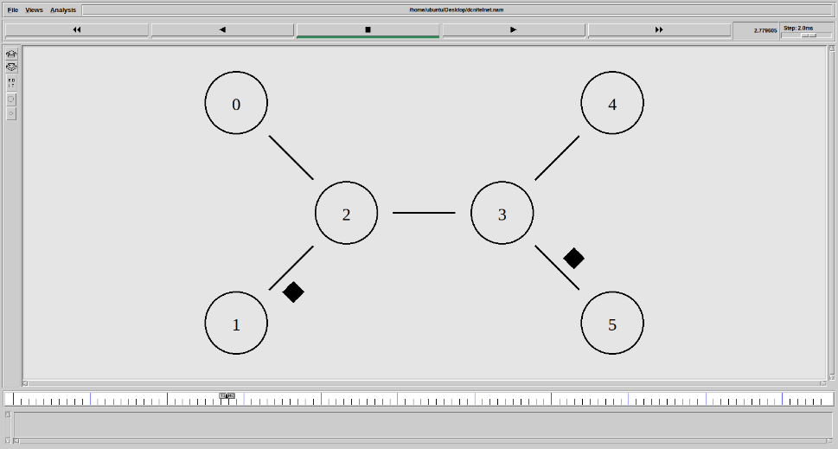

Figure 1 NAM Output

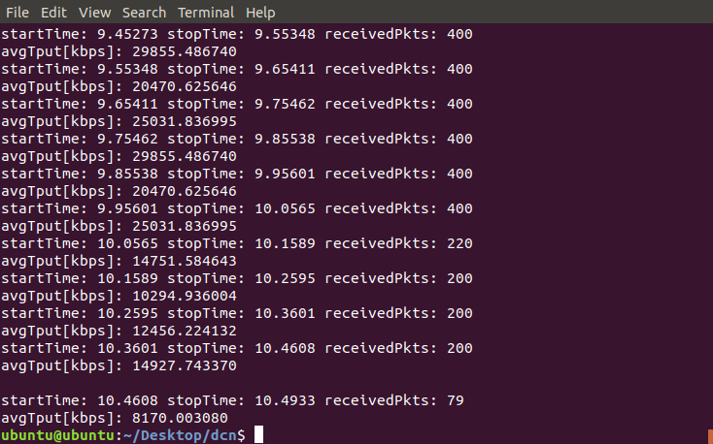

Figure 2 Avg_Tput.awk

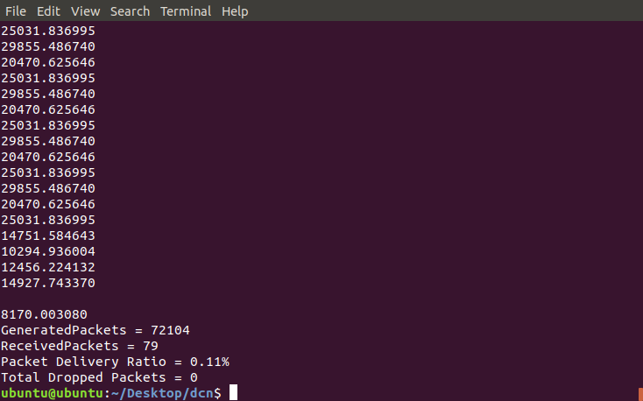

Figure 3 Pkt.awk

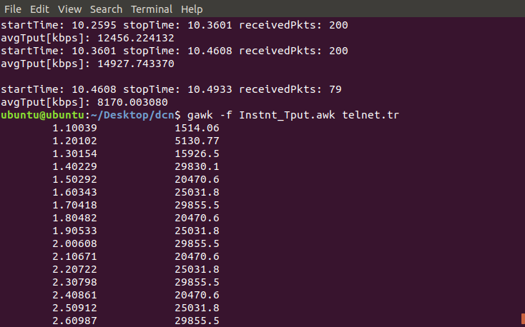

Figure 4 Instnt_Tput.awk

**RESULT:**

Simulation of TELNET and FTP between N Sources and N Sinks is done using NS2 Software.

|  |  |
| --- | --- |
| **EXPERIMENT 2** | **EFFECT OF VARIOUS QUEUEING DISCIPLINES (RED /WEIGHTED RED / ADAPTIVE RED) ON NETWORK PERFORMANCE** |

**AIM:** To Study the Effect of Various Queuing Disciplines (RED /Weighted RED /Adaptive RED) On Network Performance

**APPARATUS:** Desktop PC

**SOFTWARE USED:** Network Simulator 2 (NS2)

**THEORY:**

Queue management techniques help control network congestion by regulating how packets are queued and dropped. **Random Early Detection (RED)** is a widely used approach in queue management, and it has variants like **Weighted RED** and **Adaptive RED** to improve performance.

**1. Random Early Detection (RED)**

RED is an active queue management algorithm that prevents congestion by **randomly dropping packets before the queue is full**. It works by monitoring the average queue size and dropping packets probabilistically based on threshold values.

**2. Weighted RED (WRED)**

WRED extends RED by assigning different **drop probabilities** to different types of traffic based on priority or Quality of Service (QoS) settings. Higher-priority traffic has a lower chance of being dropped compared to lower-priority traffic. It is used in **differentiated services (DiffServ)** networks.

**3. Adaptive RED (ARED)**

Adaptive RED dynamically adjusts RED parameters based on network conditions to optimize performance. Instead of using fixed threshold values for packet dropping, ARED automatically **tunes the drop probability** to maintain a stable queue length. It reduces manual tuning of RED parameters and adapts to changing traffic patterns for better congestion control.

**PROGRAM: RED**

# Simulation parameters setup

set val(stop) 10.0 ;# time of simulation end

#===================================

# Initialization

#Create a ns simulator

set ns [new Simulator]

#Open the NS trace file

set tracefile [open queue_red.tr w]

$ns trace-all $tracefile

#Open the NAM trace file

set namfile [open queue_red.nam w]

$ns namtrace-all $namfile

#===================================

# Nodes Definition

#Create 7 nodes

set n0 [$ns node]

set n1 [$ns node]

set n2 [$ns node]

set n3 [$ns node]

set n4 [$ns node]

set n5 [$ns node]

set n6 [$ns node]

#===================================

# Links Definition

#Createlinks between nodes

$ns duplex-link $n0 $n3 100.0Mb 10ms RED

$ns queue-limit $n0 $n3 50

$ns duplex-link $n4 $n1 100.0Mb 10ms RED

$ns queue-limit $n4 $n1 50

$ns duplex-link $n6 $n5 100.0Mb 10ms RED

$ns queue-limit $n6 $n5 50

$ns duplex-link $n4 $n6 100.0Mb 10ms RED

$ns queue-limit $n4 $n6 50

$ns duplex-link $n5 $n2 100.0Mb 10ms RED

$ns queue-limit $n5 $n2 50

$ns duplex-link $n0 $n2 100.0Mb 10ms RED

$ns queue-limit $n0 $n2 50

$ns duplex-link $n2 $n1 100.0Mb 10ms RED

$ns queue-limit $n2 $n1 50

$ns duplex-link $n1 $n5 100.0Mb 10ms RED

$ns queue-limit $n1 $n5 50

$ns duplex-link $n3 $n4 100.0Mb 10ms RED

$ns queue-limit $n3 $n4 50

$ns duplex-link $n3 $n1 100.0Mb 10ms RED

$ns queue-limit $n3 $n1 50

#Give node position (for NAM)

$ns duplex-link-op $n0 $n3 orient right-up

$ns duplex-link-op $n4 $n1 orient left-down

$ns duplex-link-op $n6 $n5 orient left-down

$ns duplex-link-op $n4 $n6 orient right-down

$ns duplex-link-op $n5 $n2 orient left

$ns duplex-link-op $n0 $n2 orient right-down

$ns duplex-link-op $n2 $n1 orient right-up

$ns duplex-link-op $n1 $n5 orient right-down

$ns duplex-link-op $n3 $n4 orient right

$ns duplex-link-op $n3 $n1 orient right-down

# Agents Definition

#Setup a TCP connection

set tcp0 [new Agent/TCP]

$ns attach-agent $n0 $tcp0

set sink2 [new Agent/TCPSink]

$ns attach-agent $n4 $sink2

$ns connect $tcp0 $sink2

$tcp0 set packetSize_ 1500

#Setup a TCP/FullTcp/Tahoe connection

set tcp1 [new Agent/TCP]

$ns attach-agent $n2 $tcp1

set sink3 [new Agent/TCPSink]

$ns attach-agent $n6 $sink3

$ns connect $tcp1 $sink3

$tcp1 set packetSize_ 1500

#===================================

# Applications Definition

#Setup a FTP Application over TCP connection

set ftp0 [new Application/FTP]

$ftp0 attach-agent $tcp0

$ns at 1.0 "$ftp0 start"

$ns at 10.0 "$ftp0 stop"

#Setup a FTP Application over TCP/FullTcp/Tahoe connection

set ftp1 [new Application/FTP]

$ftp1 attach-agent $tcp1

$ns at 1.0 "$ftp1 start"

$ns at 10.0 "$ftp1 stop"

# Termination

#Define a 'finish' procedure

proc finish {} {

global ns tracefile namfile

$ns flush-trace

close $tracefile

close $namfile

exec nam queue_red.nam &

exit 0

}

$ns at $val(stop) "$ns nam-end-wireless $val(stop)"

$ns at $val(stop) "finish"

$ns at $val(stop) "puts \"done\" ; $ns halt"

$ns run

**PROGRAM: WRED**

# Simulation parameters setup #===================================

set val(stop) 10.0 ;# time of simulation end

#===================================

# Initialization #===================================

#Create a ns simulator

set ns [new Simulator]

#Open the NS trace file

set tracefile [open queue_wred.tr w]

$ns trace-all $tracefile

#Open the NAM trace file

set namfile [open queue_wred.nam w]

$ns namtrace-all $namfile

#===================================

# Nodes Definition #===================================

#Create 7 nodes

set n0 [$ns node]

set n1 [$ns node]

set n2 [$ns node]

set n3 [$ns node]

set n4 [$ns node]

set n5 [$ns node]

set n6 [$ns node]

#===================================

# Links Definition #===================================

#Create links with Weighted RED (WRED)

$ns duplex-link $n0 $n3 100.0Mb 10ms RED/Queue

$ns queue-limit $n0 $n3 50

$ns duplex-link $n4 $n1 100.0Mb 10ms RED/Queue

$ns queue-limit $n4 $n1 50

$ns duplex-link $n6 $n5 100.0Mb 10ms RED/Queue

$ns queue-limit $n6 $n5 50

$ns duplex-link $n4 $n6 100.0Mb 10ms RED/Queue

$ns queue-limit $n4 $n6 50

$ns duplex-link $n5 $n2 100.0Mb 10ms RED/Queue

$ns queue-limit $n5 $n2 50

$ns duplex-link $n0 $n2 100.0Mb 10ms RED/Queue

$ns queue-limit $n0 $n2 50

$ns duplex-link $n2 $n1 100.0Mb 10ms RED/Queue

$ns queue-limit $n2 $n1 50

$ns duplex-link $n1 $n5 100.0Mb 10ms RED/Queue

$ns queue-limit $n1 $n5 50

$ns duplex-link $n3 $n4 100.0Mb 10ms RED/Queue

$ns queue-limit $n3 $n4 50

$ns duplex-link $n3 $n1 100.0Mb 10ms RED/Queue

$ns queue-limit $n3 $n1 50

# Weighted RED Configuration

Queue/RED set gentle_ true

Queue/RED set thresh_ 20

Queue/RED set maxthresh_ 40

Queue/RED set weight_ 0.002

Queue/RED set linterm_ 10

Queue/RED set q_weight_ 0.003

#Give node position (for NAM)

$ns duplex-link-op $n0 $n3 orient right-up

$ns duplex-link-op $n4 $n1 orient left-down

$ns duplex-link-op $n6 $n5 orient left-down

$ns duplex-link-op $n4 $n6 orient right-down

$ns duplex-link-op $n5 $n2 orient left

$ns duplex-link-op $n0 $n2 orient right-down

$ns duplex-link-op $n2 $n1 orient right-up

$ns duplex-link-op $n1 $n5 orient right-down

$ns duplex-link-op $n3 $n4 orient right

$ns duplex-link-op $n3 $n1 orient right-down

#===================================

# Agents Definition #===================================

#Setup a TCP connection

set tcp0 [new Agent/TCP]

$ns attach-agent $n0 $tcp0

set sink2 [new Agent/TCPSink]

$ns attach-agent $n4 $sink2

$ns connect $tcp0 $sink2

$tcp0 set packetSize_ 1500

#Setup a TCP/FullTcp/Tahoe connection

set tcp1 [new Agent/TCP]

$ns attach-agent $n2 $tcp1

set sink3 [new Agent/TCPSink]

$ns attach-agent $n6 $sink3

$ns connect $tcp1 $sink3

$tcp1 set packetSize_ 1500

#===================================

# Applications Definition #===================================

#Setup a FTP Application over TCP connection

set ftp0 [new Application/FTP]

$ftp0 attach-agent $tcp0

$ns at 1.0 "$ftp0 start"

$ns at 10.0 "$ftp0 stop"

#Setup a FTP Application over TCP/FullTcp/Tahoe connection

set ftp1 [new Application/FTP]

$ftp1 attach-agent $tcp1

$ns at 1.0 "$ftp1 start"

$ns at 10.0 "$ftp1 stop"

#===================================

# Termination #===================================

#Define a 'finish' procedure

proc finish {} {

global ns tracefile namfile

$ns flush-trace

close $tracefile

close $namfile

exec nam queue_wred.nam &

exit 0

}

$ns at $val(stop) "$ns nam-end-wireless $val(stop)"

$ns at $val(stop) "finish"

$ns at $val(stop) "puts \"done\" ; $ns halt"

$ns run

**PROGRAM: ARED**

# Simulation parameters setup #===================================

set val(stop) 10.0 ;# time of simulation end

#===================================

# Initialization #===================================

#Create a ns simulator

set ns [new Simulator]

#Open the NS trace file

set tracefile [open queue_ared.tr w]

$ns trace-all $tracefile

#Open the NAM trace file

set namfile [open queue_ared.nam w]

$ns namtrace-all $namfile

#===================================

# Nodes Definition #===================================

#Create 7 nodes

set n0 [$ns node]

set n1 [$ns node]

set n2 [$ns node]

set n3 [$ns node]

set n4 [$ns node]

set n5 [$ns node]

set n6 [$ns node]

#===================================

# Links Definition #===================================

#Create links with Adaptive RED (ARED)

$ns duplex-link $n0 $n3 100.0Mb 10ms RED/ARED

$ns queue-limit $n0 $n3 50

$ns duplex-link $n4 $n1 100.0Mb 10ms RED/ARED

$ns queue-limit $n4 $n1 50

$ns duplex-link $n6 $n5 100.0Mb 10ms RED/ARED

$ns queue-limit $n6 $n5 50

$ns duplex-link $n4 $n6 100.0Mb 10ms RED/ARED

$ns queue-limit $n4 $n6 50

$ns duplex-link $n5 $n2 100.0Mb 10ms RED/ARED

$ns queue-limit $n5 $n2 50

$ns duplex-link $n0 $n2 100.0Mb 10ms RED/ARED

$ns queue-limit $n0 $n2 50

$ns duplex-link $n2 $n1 100.0Mb 10ms RED/ARED

$ns queue-limit $n2 $n1 50

$ns duplex-link $n1 $n5 100.0Mb 10ms RED/ARED

$ns queue-limit $n1 $n5 50

$ns duplex-link $n3 $n4 100.0Mb 10ms RED/ARED

$ns queue-limit $n3 $n4 50

$ns duplex-link $n3 $n1 100.0Mb 10ms RED/ARED

$ns queue-limit $n3 $n1 50

# Adaptive RED Configuration

Queue/RED set adaptive_ true

Queue/RED set thresh_ 20

Queue/RED set maxthresh_ 40

Queue/RED set q_weight_ 0.002

Queue/RED set linterm_ 10

Queue/RED set gentle_ true

Queue/RED set adaptive_max_p_ 0.02

Queue/RED set adaptive_incr_ 0.01

Queue/RED set adaptive_decr_ 0.00001

#Give node position (for NAM)

$ns duplex-link-op $n0 $n3 orient right-up

$ns duplex-link-op $n4 $n1 orient left-down

$ns duplex-link-op $n6 $n5 orient left-down

$ns duplex-link-op $n4 $n6 orient right-down

$ns duplex-link-op $n5 $n2 orient left

$ns duplex-link-op $n0 $n2 orient right-down

$ns duplex-link-op $n2 $n1 orient right-up

$ns duplex-link-op $n1 $n5 orient right-down

$ns duplex-link-op $n3 $n4 orient right

$ns duplex-link-op $n3 $n1 orient right-down

#===================================

# Agents Definition #===================================

#Setup a TCP connection

set tcp0 [new Agent/TCP]

$ns attach-agent $n0 $tcp0

set sink2 [new Agent/TCPSink]

$ns attach-agent $n4 $sink2

$ns connect $tcp0 $sink2

$tcp0 set packetSize_ 1500

#Setup a TCP/FullTcp/Tahoe connection

set tcp1 [new Agent/TCP]

$ns attach-agent $n2 $tcp1

set sink3 [new Agent/TCPSink]

$ns attach-agent $n6 $sink3

$ns connect $tcp1 $sink3

$tcp1 set packetSize_ 1500

#===================================

# Applications Definition #===================================

#Setup a FTP Application over TCP connection

set ftp0 [new Application/FTP]

$ftp0 attach-agent $tcp0

$ns at 1.0 "$ftp0 start"

$ns at 10.0 "$ftp0 stop"

#Setup a FTP Application over TCP/FullTcp/Tahoe connection

set ftp1 [new Application/FTP]

$ftp1 attach-agent $tcp1

$ns at 1.0 "$ftp1 start"

$ns at 10.0 "$ftp1 stop"

#===================================

# Termination #===================================

#Define a 'finish' procedure

proc finish {} {

global ns tracefile namfile

$ns flush-trace

close $tracefile

close $namfile

exec nam queue_ared.nam &

exit 0

}

$ns at $val(stop) "$ns nam-end-wireless $val(stop)"

$ns at $val(stop) "finish"

$ns at $val(stop) "puts \"done\" ; $ns halt"

$ns run

**PROCEDURE:**

* Turn The Pc On And Log Into Your Account. Linux OS Is Needed To Run NS2.
* Navigate To Your Directory.
* Open A Terminal Window In The Directory And Enter The Following Commands To Enter And Save The Code.

gedit exp2.tcl

* A Text Editor Window Is Opened. Enter Your Script And Save The File.
* Now, Enter The Following Command To Run The Simulation.

ns exp2.tcl

* A NAM Window Will Be Opened Displaying The Network Model. Observe The Behavior Of The Network.
* The Outputs Are Observed And Readings Are Noted Down.

**OUTPUTS:**

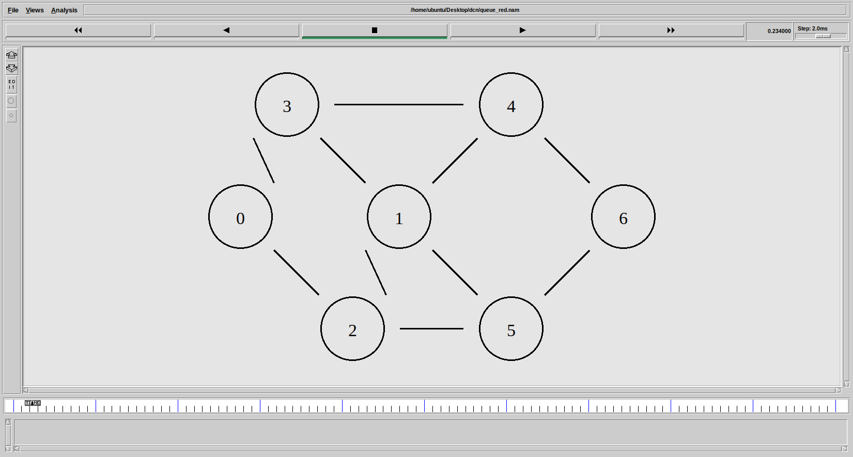

Figure 5 NAM Output

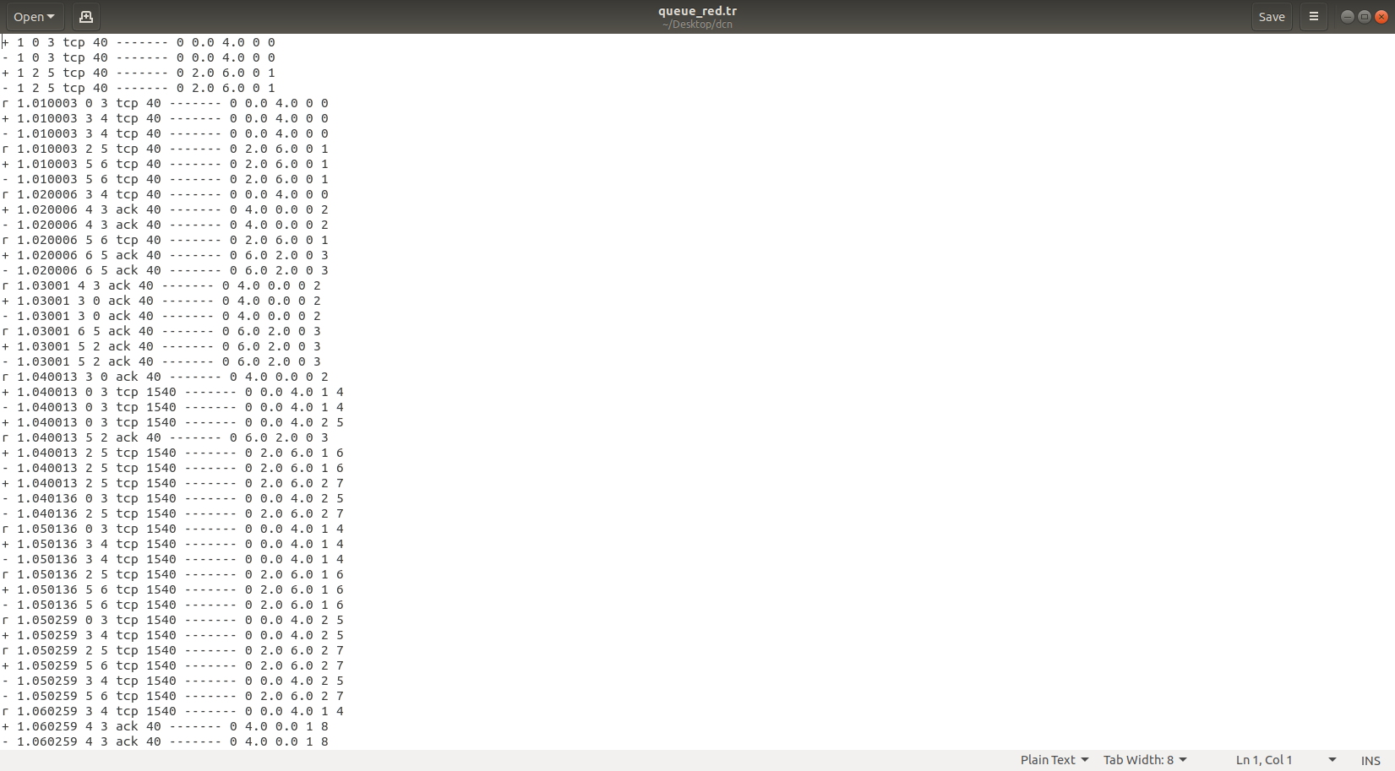

Figure 6 Tracefile:RED

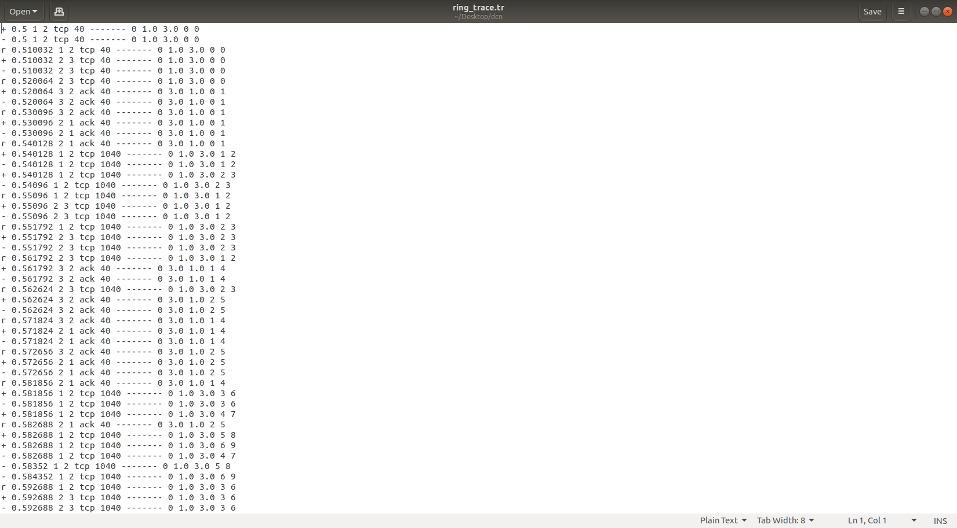

Figure 7 Tracefile:WRED

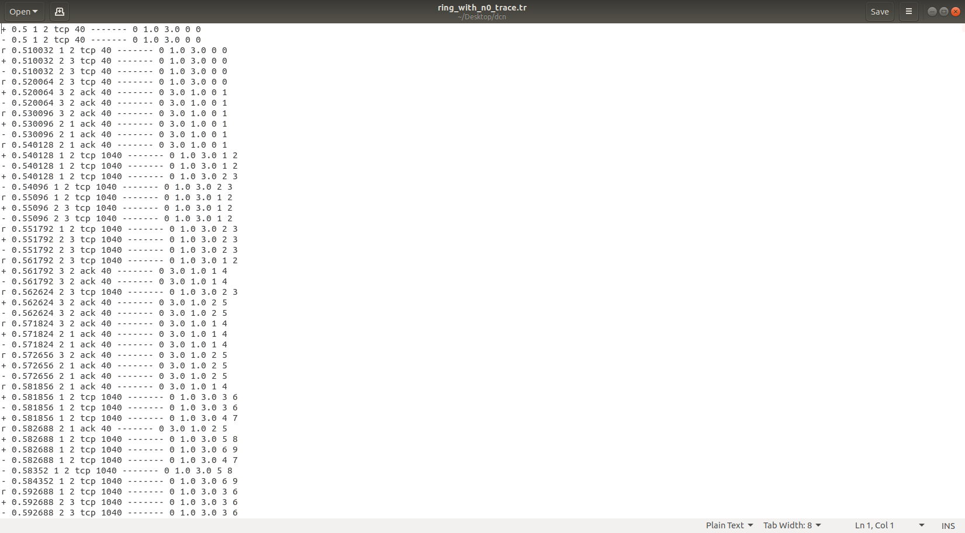

Figure 8 Tracefile:ARED

**RESULT:**

The Effect of Various Queuing Disciplines (RED /Weighted RED /Adaptive RED) On Network Performance is Observed Using NS2 Software.

|  |  |
| --- | --- |
| **EXPERIMENT 3** | **SIMULATION OF FTP, HTTP, DBMS ACCESS IN NETWORKS** |

**AIM:** To simulate http, ftp and DBMS access in networks

**APPARATUS:** Desktop PC

**SOFTWARE USED:** Network Simulator 2 (NS2)

**THEORY:**

**1. HTTP (Hypertext Transfer Protocol)**

* **Purpose:** HTTP is a protocol used for transferring hypertext (web pages) from a web server to a web browser (client).
* **Port Number:** 80 (Default)
* **Working:**
  + The client sends a **HTTP request** (GET, POST, PUT and DELETE) to the server.
  + The server responds with a **HTTP response** containing the requested resource (web page, image, etc.).
* **Stateless Protocol:** Each request-response is independent, meaning no information is retained between requests.
* **Secure Version:** HTTPS (uses SSL/TLS encryption)

**2. FTP (File Transfer Protocol)**

* **Purpose:** FTP is used for transferring files between a **client** and a **server** in a network.
* **Port Number:**
  + **21:** Control connection (for commands)
  + **20:** Data connection (for file transfer)
* **Modes:**
  + **Active Mode:** Server actively establishes a data connection.
  + **Passive Mode:** Client requests a data connection from the server.
* **Commands:**
  + PUT → Upload files from client to server.
  + GET → Download files from server to client.

**3. DBMS Access in Networks**

* **Purpose:** DBMS (Database Management System) access in networks allows remote applications or users to access and manipulate data stored in a centralized database server.
* **Protocol Used:**
  + **ODBC (Open Database Connectivity)**
  + **JDBC (Java Database Connectivity)**
* **Port Numbers:**
  + **3306:** MySQL Database
  + **1433:** MS-SQL Server
  + **1521:** Oracle Database

**PROGRAM:**

#==================================

# NS2 Simulation for HTTP, FTP, DBMS Access

#==================================

# Simulation Parameters

set val(stop) 10.0 ;# Simulation Stop Time

# Initialize the Simulator

set ns [new Simulator]

# Trace Files

set tracefile [open network_access.tr w]

$ns trace-all $tracefile

set namfile [open network_access.nam w]

$ns namtrace-all $namfile

# Create Nodes

set n0 [$ns node] ;# HTTP Client

set n1 [$ns node] ;# HTTP Server

set n2 [$ns node] ;# FTP Client

set n3 [$ns node] ;# FTP Server

set n4 [$ns node] ;# DBMS Client

set n5 [$ns node] ;# DBMS Server

#==================================

# Link Creation

#==================================

# Link between HTTP Client and HTTP Server

$ns duplex-link $n0 $n1 100Mb 10ms DropTail

# Link between FTP Client and FTP Server

$ns duplex-link $n2 $n3 100Mb 10ms DropTail

# Link between DBMS Client and DBMS Server

$ns duplex-link $n4 $n5 100Mb 10ms DropTail

# Set Queue Size

$ns queue-limit $n0 $n1 50

$ns queue-limit $n2 $n3 50

$ns queue-limit $n4 $n5 50

#==================================

# HTTP Simulation Setup

#==================================

# Create TCP Agent for HTTP Traffic

set tcp_http [new Agent/TCP]

$ns attach-agent $n0 $tcp_http

# Create Sink Agent

set sink_http [new Agent/TCPSink]

$ns attach-agent $n1 $sink_http

# Connect the Agents

$ns connect $tcp_http $sink_http

$tcp_http set packetSize_ 512

# Create HTTP Traffic (Application Layer)

set http [new Application/Traffic/Exponential]

$http attach-agent $tcp_http

$http set rate_ 2Mb

$http set burst_time_ 2.0

$http set idle_time_ 1.0

# Start HTTP Traffic

$ns at 1.0 "$http start"

$ns at 9.0 "$http stop"

#==================================

# FTP Simulation Setup

#==================================

# Create TCP Agent for FTP Traffic

set tcp_ftp [new Agent/TCP]

$ns attach-agent $n2 $tcp_ftp

# Create Sink Agent

set sink_ftp [new Agent/TCPSink]

$ns attach-agent $n3 $sink_ftp

# Connect the Agents

$ns connect $tcp_ftp $sink_ftp

$tcp_ftp set packetSize_ 1500

# Create FTP Application

set ftp [new Application/FTP]

$ftp attach-agent $tcp_ftp

# Start FTP Traffic

$ns at 2.0 "$ftp start"

$ns at 8.0 "$ftp stop"

#==================================

# DBMS Access Simulation Setup

#==================================

# Create TCP Agent for DBMS Access

set tcp_db [new Agent/TCP]

$ns attach-agent $n4 $tcp_db

# Create Sink Agent

set sink_db [new Agent/TCPSink]

$ns attach-agent $n5 $sink_db

# Connect the Agents

$ns connect $tcp_db $sink_db

$tcp_db set packetSize_ 1000

# Simulate Database Access with CBR Traffic (DBMS Query)

set db_query [new Application/Traffic/CBR]

$db_query attach-agent $tcp_db

$db_query set rate_ 1Mb

$db_query set packetSize_ 1000

$db_query set interval_ 0.01

# Start Database Access Traffic

$ns at 3.0 "$db_query start"

$ns at 7.0 "$db_query stop"

#==================================

# Termination Setup

#==================================

proc finish {} {

global ns tracefile namfile

$ns flush-trace

close $tracefile

close $namfile

exec nam network_access.nam &

exit 0

}

$ns at $val(stop) "finish"

$ns at $val(stop) "puts \"Simulation Complete\" ; $ns halt"

# Run the Simulation

$ns run

**PROCEDURE:**

* Turn The Pc On And Log Into Your Account. Linux OS Is Needed To Run NS2.
* Navigate To Your Directory.
* Open A Terminal Window In The Directory And Enter The Following Commands To Enter And Save The Code.

gedit exp3.tcl

* A Text Editor Window Is Opened. Enter Your Script And Save The File.
* Now, Enter The Following Command To Run The Simulation.

ns exp3.tcl

* A NAM Window Will Be Opened Displaying The Network Model. Observe The Behavior Of The Network.
* The Outputs Are Observed And Readings Are Noted Down.

**OUTPUTS:**

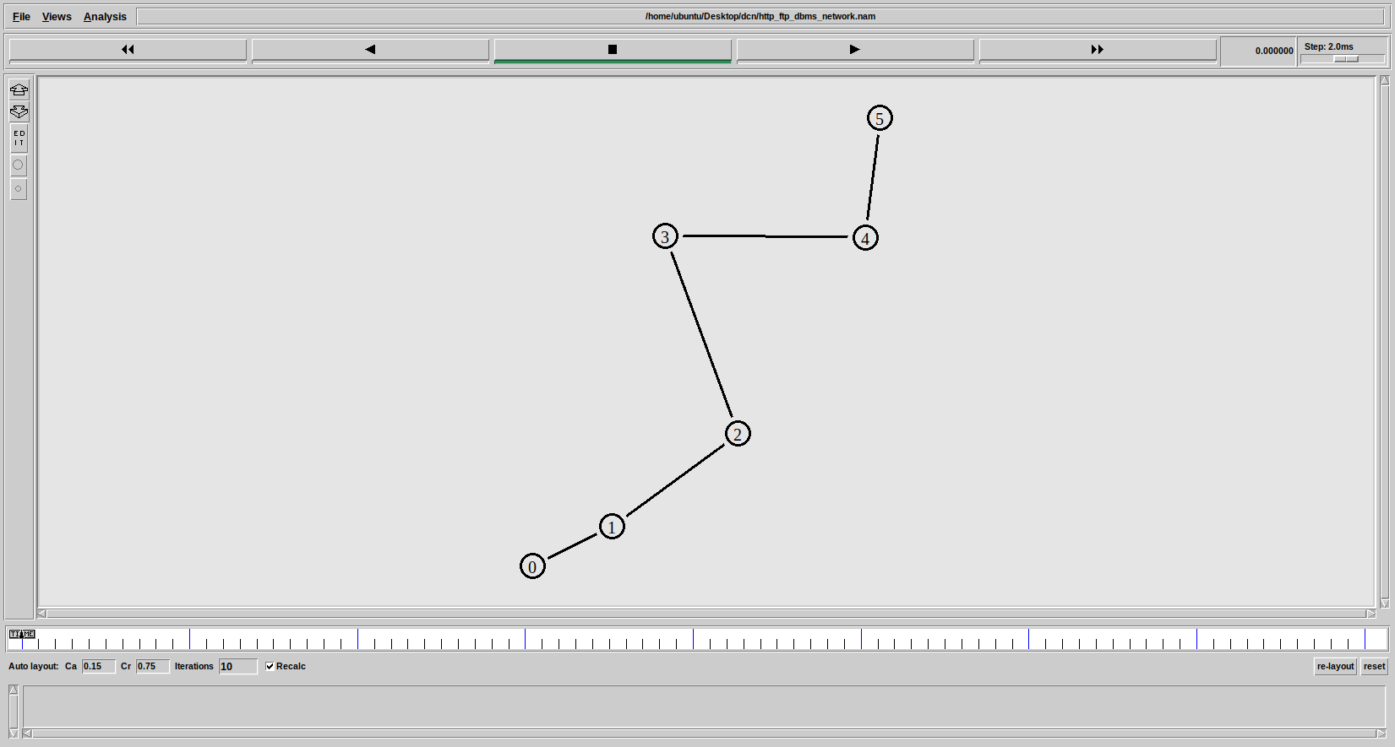

Figure 9: NAM Output

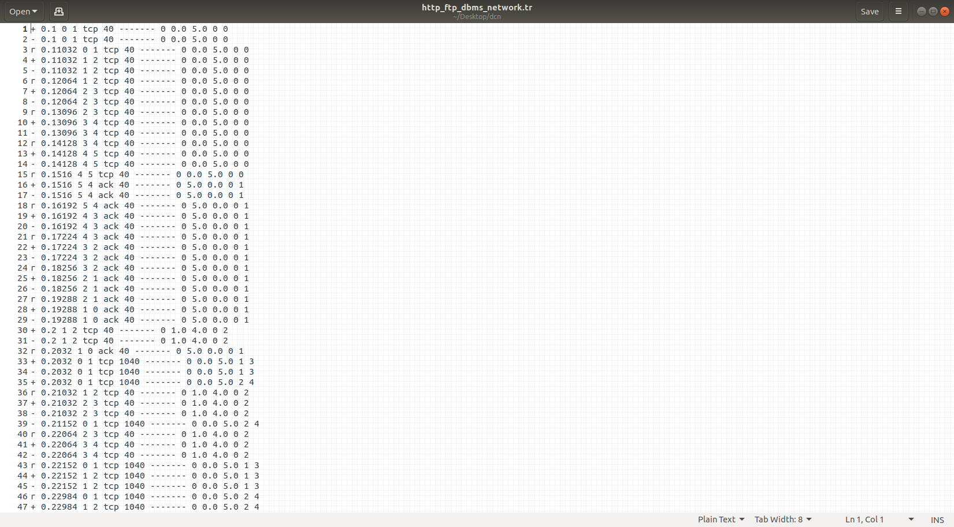

Figure 10 Tracefile

**RESULT:**

Simulation of HTTP, FTP, DBMS Access in Networks is Done Using NS2 Software.

|  |  |
| --- | --- |
| **EXPERIMENT 4** | **SIMULATION OF SLIDING WINDOW PROTOCOL** |

**AIM:** To simulate sliding window protocol.

**APPARATUS:** Desktop PC

**SOFTWARE USED:** Network Simulator 2 (NS2)

**THEORY:**

The **Sliding Window Protocol (SWP)** is a **flow control protocol** used in **Data Link Layer (Layer 2)** and **Transport Layer (Layer 4)** to ensure **efficient and reliable** transmission of data between two devices over a network.

It is mainly used in:

* **TCP (Transmission Control Protocol)**.
* **Data Link Layer (for error and flow control)**.

• A **"window"** refers to the number of **packets (frames)** that can be sent before **waiting for an acknowledgment (ACK)**.

• As **ACKs** are received, the window **slides** forward to allow the sender to transmit more packets.

**PROGRAM:**

# Define a network simulator

set ns [new Simulator]

# Create a trace file

set tracefile [open "output.tr" w]

$ns trace-all $tracefile

# Create nodes

set sender [$ns node]

set receiver [$ns node]

# Create a link between sender and receiver

$ns duplex-link $sender $receiver 1Mb 10ms DropTail

# Define the traffic type (TCP)

set tcp [new Agent/TCP]

$ns attach-agent $sender $tcp

# Define TCP sink

set sink [new Agent/TCPSink]

$ns attach-agent $receiver $sink

# Connect TCP agent and sink

$ns connect $tcp $sink

# Set sliding window size

$tcp set window_ 4 ;# Example: Window size = 4 frames

# Define traffic source

set ftp [new Application/FTP]

$ftp attach-agent $tcp

# Schedule events

$ns at 0.1 "$ftp start"

$ns at 5.0 "$ftp stop"

$ns at 5.1 "finish"

# Define finish procedure

proc finish {} {

global ns tracefile

$ns flush-trace

close $tracefile

exit 0

}

# Run the simulation

$ns run

**ANALYZE.AWK:**

BEGIN {

sent = 0; received = 0; dropped = 0; total_delay = 0;}

# Count sent packets

$1 == "+" { sent++; send_time[$11] = $2; }

# Count received packets and calculate delay

$1 == "r" {

received++;

if ($11 in send_time) {

total_delay += ($2 - send_time[$11]);

delete send_time[$11];

}

}

# Count dropped packets

$1 == "d" { dropped++; }

END {

throughput = (received * 1024 * 8) / 5.0; # Assuming 5s simulation time

avg_delay = (received > 0) ? total_delay / received : 0;

drop_rate = (sent > 0) ? (dropped / sent) * 100 : 0;

printf("Throughput: %.2f bps\n", throughput);

printf("Average Delay: %.2f ms\n", avg_delay * 1000);

printf("Packet Drop Rate: %.2f%%\n", drop_rate);

}

**PROCEDURE:**

* Turn The Pc On And Log Into Your Account. Linux OS Is Needed To Run NS2.
* Navigate To Your Directory.
* Open A Terminal Window In The Directory And Enter The Following Commands To Enter And Save The Code.

gedit exp4.tcl

* A Text Editor Window Is Opened. Enter Your Script And Save The File.
* Now, Enter The Following Command To Run The Simulation.

ns exp4.tcl

* A NAM Window Will Be Opened Displaying The Network Model. Observe The Behavior Of The Network.
* For Further Analysis We Need .Awk Script Files. Copy These Files To The Same Folder As The NS2 Script.
* The .awk Files Can Be Executed By Using The Following Command:

awk –f analyze.awk tracefile.tr

* The Outputs Are Observed And Readings Are Noted Down.

**OUTPUTS:**

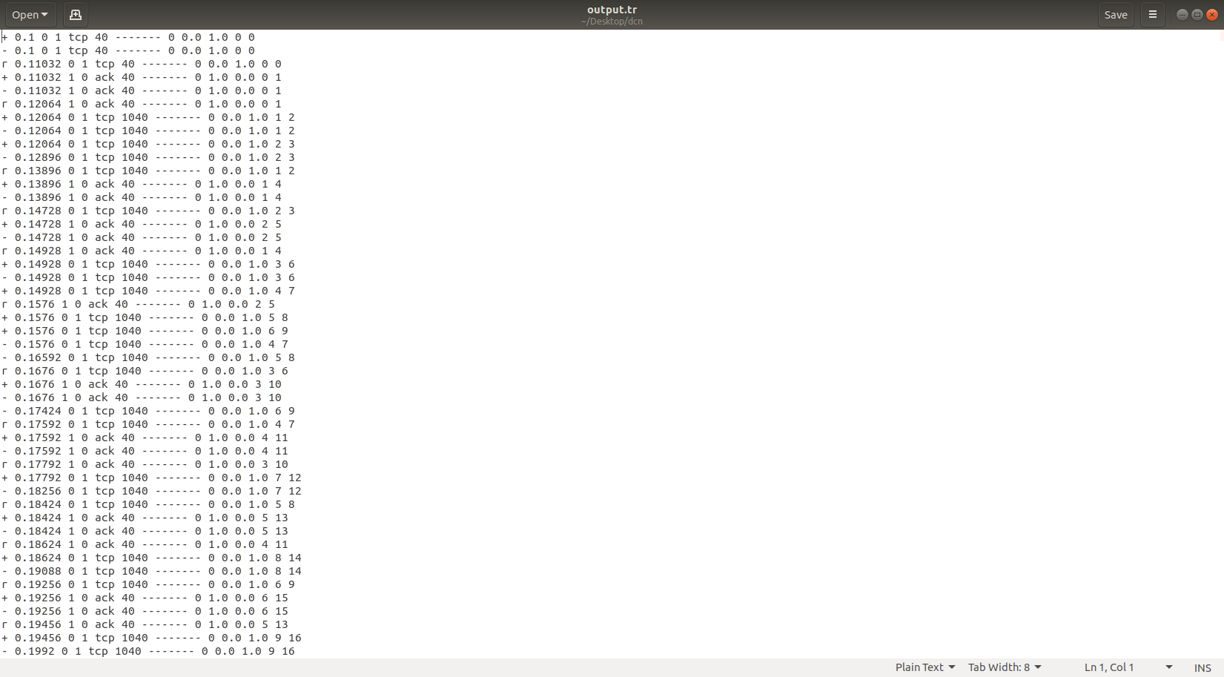

Figure 11 Tracefile

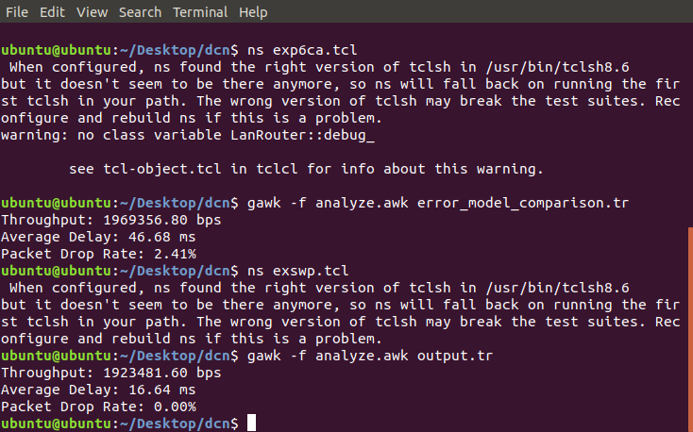

Figure 12 Analyze.awk Output

**RESULT:**

Simulation of Sliding Window Protocol is Done Using NS2 Software.

|  |  |
| --- | --- |
| **EXPERIMENT 5** | **SIMULATION OF GO BACK N, SELECTIVE REPEAT PROTOCOLS** |

**AIM:** To simulate GoBackN and Selective Repeat Protocols using NS2.

**APPARATUS:** Desktop PC

**SOFTWARE USED:** Network Simulator 2 (NS2)

**THEORY:**

The Go-Back-N protocol is a sliding window protocol used for reliable data transfer in computer networks. It is a sender-based protocol that allows the sender to transmit multiple packets without waiting for an acknowledgement for each packet. The receiver sends a cumulative acknowledgement for a sequence of packets, indicating the last correctly received packet. If any packet is lost, the receiver sends a negative acknowledgement (NACK) for the lost packet, and the sender retransmits all the packets in the window starting from the lost packet. The sender also maintains a timer for each packet, and if an acknowledgement is not received within the timer’s timeout period, the sender retransmits all packets in the window.

The Selective Repeat protocol is another the used for reliable data transfer in computer networks. It is a receiver-based protocol that allows the receiver to acknowledge each packet individually, rather than a cumulative acknowledgement of a sequence of packets. The sender sends packets in a window and waits for acknowledgements for each packet in the window. If a packet is lost, the receiver sends a NACK for the lost packet, and the sender retransmits only that packet. The sender also maintains a timer for each packet, and if an acknowledgement is not received within the timer’s timeout period, the sender retransmits only that packet.

**PROGRAM:**

# Define a network simulator

set ns [new Simulator]

# Create trace file for simulation analysis

set tracefile [open "error_model_comparison.tr" w]

$ns trace-all $tracefile

# Create nodes

set sender [$ns node]

set receiver [$ns node]

# Create a link between sender and receiver

$ns duplex-link $sender $receiver 1Mb 10ms DropTail

# Define error model (Uniform Error Model)

# This introduces packet loss in the link

set loss_model [new ErrorModel]

$loss_model set rate_ 0.05 ;# 5% packet loss

$loss_model unit pkt

$loss_model ranvar [new RandomVariable/Uniform]

$loss_model drop-target [new Agent/Null]

$ns lossmodel $loss_model $sender $receiver

# Function to configure and simulate Go-Back-N or Selective Repeat

proc simulate {protocol_type window_size simulation_time} {

global ns sender receiver tracefile

set tcp [new Agent/TCP]

$tcp set class_ $protocol_type ;# Set protocol: TCP/GoBackN or TCP/SelectiveRepeat

$tcp set window_ $window_size ;# Configure sliding window size

set sink [new Agent/TCPSink]

$ns attach-agent $sender $tcp

$ns attach-agent $receiver $sink

$ns connect $tcp $sink

set ftp [new Application/FTP]

$ftp attach-agent $tcp

$ns at 0.1 "$ftp start"

$ns at $simulation_time "$ftp stop" }

# Simulate Go-Back-N (GBN) with varying window sizes

puts "Simulating Go-Back-N..."

simulate "GoBackN" 4 5.0 ;# GBN with window size 4

simulate "GoBackN" 8 5.0 ;# GBN with window size 8

# Simulate Selective Repeat (SR) with varying window sizes

puts "Simulating Selective Repeat..."

simulate "SelectiveRepeat" 4 5.0 ;# SR with window size 4

simulate "SelectiveRepeat" 8 5.0 ;# SR with window size 8

# Define finish procedure

proc finish {} {

global ns tracefile

$ns flush-trace

close $tracefile

exit 0 }

# Schedule simulation end

$ns at 6.0 "finish"

# Run the simulation

$ns run

**ANALYZE.AWK:**

BEGIN {

sent = 0; received = 0; dropped = 0; total_delay = 0;}

# Count sent packets

$1 == "+" { sent++; send_time[$11] = $2; }

# Count received packets and calculate delay

$1 == "r" {

received++;

if ($11 in send_time) {

total_delay += ($2 - send_time[$11]);

delete send_time[$11];

}

}

# Count dropped packets

$1 == "d" { dropped++; }

END {

throughput = (received * 1024 * 8) / 5.0; # Assuming 5s simulation time

avg_delay = (received > 0) ? total_delay / received : 0;

drop_rate = (sent > 0) ? (dropped / sent) * 100 : 0;

printf("Throughput: %.2f bps\n", throughput);

printf("Average Delay: %.2f ms\n", avg_delay * 1000);

printf("Packet Drop Rate: %.2f%%\n", drop_rate);

}

**PROCEDURE:**

* Turn The Pc On And Log Into Your Account. Linux OS Is Needed To Run NS2.
* Navigate To Your Directory.
* Open A Terminal Window In The Directory And Enter The Following Commands To Enter And Save The Code.

gedit exp5.tcl

* A Text Editor Window Is Opened. Enter Your Script And Save The File.
* Now, Enter The Following Command To Run The Simulation.

ns exp5.tcl

* A NAM Window Will Be Opened Displaying The Network Model. Observe The Behavior Of The Network.
* For Further Analysis We Need .Awk Script Files. Copy These Files To The Same Folder As The NS2 Script.
* The .awk Files Can Be Executed By Using The Following Command:

awk –f analyze.awk tracefile.tr

* The Outputs Are Observed And Readings Are Noted Down.

**OUTPUTS:**

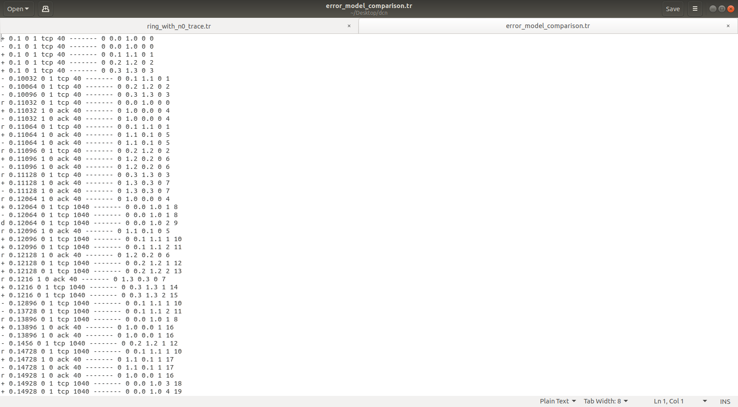

Figure 13 Tracefile Output

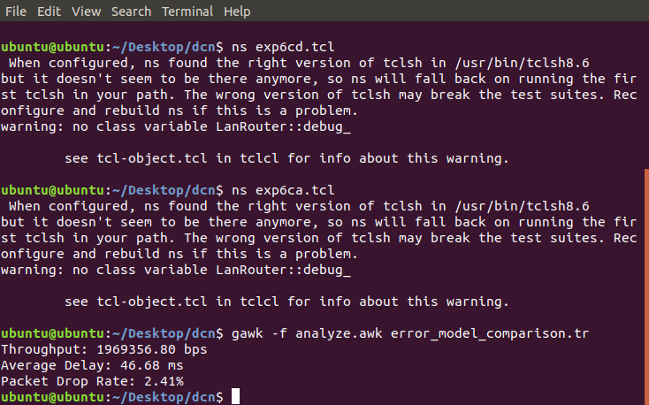

Figure 14 Analyze.awk Output

**RESULT:**

Comparison of Go Back N Protocol and Selective Repeat Protocol is Done Using NS2 Software.

|  |  |
| --- | --- |
| **EXPERIMENT 6** | **COMPARISION OF CSMA/CA AND CSMA/CD PROTOCOLS** |

**AIM:** To study the performance of network with CSMA/CA protocol and compare with CSMA/CD protocols.

**APPARATUS:** Desktop PC

**SOFTWARE USED:** Network Simulator 2 (NS2)

**THEORY:**

CSMA/CA stands for Carrier Sense Multiple Access / Collision Avoidance is a network protocol for carrier transmission. Like CSMA/CD it is also operated in the medium access control layer. Unlike CSMA/CD (that is effective after a collision) CSMA / CA is effective before a collision. CSMA/CA reduces the chances of collisions by checking whether network channel is free or not before sending data. This is useful in wireless networks where collisions can interrupt communication. It is suitable for wireless system as it avoids collisions, by maintaining smoother connection.

CSMA/CD stands for Carrier Sense Multiple Access / Collision Detection is a network protocol for carrier transmission. It is operated in the medium access control layer. It senses that the shared channel is busy broadcasting and interrupts the broadcast until the channel is free. In CSMA/CD collision is detected by broadcast sensing from the other stations. Upon collision detection in CSMA/CD, the transmission is stopped, and a jam signal is sent by the stations and then the station waits for a random time context before retransmission. It works well in wired network like Ethernet, as it is easier to detect both the Collision and response quickly, making it ideal and efficient for wired network. It is easier to implement in wired environments, especially in networks where traffic is manageable and the chances of collision is also lower.

**PROGRAM: CSMA/CA:**

set ns [new Simulator]

#Define different colors for data flows (for NAM)

$ns color 1 Blue

$ns color 2 Red

#Open the Trace files

set file1 [open out.tr w]

set winfile [open WinFile w]

$ns trace-all $file1

#Open the NAM trace files

set file2 [open out.nam w]

$ns namtrace-all $file2

#Define a 'finish' procedure

proc finish {} {

global ns file1 file2

$ns flush-trace

close $file1

close $file2

exec nam out.nam &

exit 0 }

#Create six nodes

set n0 [$ns node]

set n1 [$ns node]

set n2 [$ns node]

set n3 [$ns node]

set n4 [$ns node]

set n5 [$ns node]

$n1 color red

$n1 shape box

#Create links between the nodes

$ns duplex-link $n0 $n2 2Mb 10ms DropTail

$ns duplex-link $n1 $n2 2Mb 10ms DropTail

$ns simplex-link $n2 $n3 0.3Mb 100ms DropTail

$ns simplex-link $n3 $n2 0.3Mb 100ms DropTail

set lan [$ns newLan "$n3 $n4 $n5" 0.5Mb 40ms LL Queue/DropTailMAC/Csma/Ca Channel]

#Setup a TCP connection

set tcp [new Agent/TCP/Newreno]

$ns attach-agent $n0 $tcp

set sink [new Agent/TCPSink/DelAck]

$ns attach-agent $n4 $sink

$ns connect $tcp $sink

$tcp set fid_ 1

$tcp set window_ 8000

$tcp set packetSize_ 552

#Setup a FTP over TCP connection

set ftp [new Application/FTP]

$ftp attach-agent $tcp

$ftp set type_ FTP

#Setup a UDP connection

set udp [new Agent/UDP]

$ns attach-agent $n1 $udp

set null [new Agent/Null]

$ns attach-agent $n5 $null

$ns connect $udp $null

$udp set fid_ 2

#Setup a CBR over UDP connection

set cbr [new Application/Traffic/CBR]

$cbr attach-agent $udp

$cbr set type_ CBR

$cbr set packet_size_ 1000

$cbr set rate_ 0.01mb

$cbr set random_ false

$ns at 0.1 "$cbr start"

$ns at 1.0 "$ftp start"

$ns at 124.0 "$ftp stop"

$ns at 124.5 "$cbr stop"

# next procedure gets two arguments: the name of the # tcp source node, will be called here "tcp",

# and the name of output file.

proc plotWindow {tcpSource file} {

global ns

set time 0.1

set now [$ns now]

set cwnd [$tcpSource set cwnd_]

set wnd [$tcpSource set window_]

puts $file "$now $cwnd"

$ns at [expr $now+$time] "plotWindow $tcpSource $file" }

$ns at 0.1 "plotWindow $tcp $winfile"

$ns at 5 "$ns trace-annotate \"packet drop\""

# PPP

$ns at 125.0 "finish"

$ns run

**PROGRAM: CSMA/CD:**

set ns [new Simulator]

#Define different colors for data flows (for NAM)

$ns color 1 Blue

$ns color 2 Red

#Open the Trace files

set file1 [open out.tr w]

set winfile [open WinFile w]

$ns trace-all $file1

#Open the NAM trace file

set file2 [open out.nam w]

$ns namtrace-all $file2

#Define a 'finish' procedure

proc finish {} {

global ns file1 file2

$ns flush-trace

close $file1

close $file2

exec nam out.nam

exit 0 }

#Create six nodes

set n0 [$ns node]

set n1 [$ns node]

set n2 [$ns node]

set n3 [$ns node]

set n4 [$ns node]

set n5 [$ns node]

$n1 color red

$n1 shape box

#Create links between the nodes

$ns duplex-link $n0 $n2 2Mb 10ms DropTail

$ns duplex-link $n1 $n2 2Mb 10ms DropTail

$ns simplex-link $n2 $n3 0.3Mb 100ms DropTail

$ns simplex-link $n3 $n2 0.3Mb 100ms DropTail

set lan [$ns newLan "$n3 $n4 $n5" 0.5Mb 40ms LL Queue/DropTailMAC/Csma/Cd Channel]

#Setup a TCP connection

set tcp [new Agent/TCP/Newreno]

$ns attach-agent $n0 $tcp

set sink [new Agent/TCPSink/DelAck]

$ns attach-agent $n4 $sink

$ns connect $tcp $sink

$tcp set fid_ 1

$tcp set window_ 8000

$tcp set packetSize_ 552

#Setup a FTP over TCP connection

set ftp [new Application/FTP]

$ftp attach-agent $tcp

$ftp set type_ FTP

#Setup a UDP connection

set udp [new Agent/UDP]

$ns attach-agent $n1 $udp

set null [new Agent/Null]

$ns attach-agent $n5 $null

$ns connect $udp $null

$udp set fid_ 2

#Setup a CBR over UDP connection

set cbr [new Application/Traffic/CBR]

$cbr attach-agent $udp

$cbr set type_ CBR

$cbr set packet_size_ 1000

$cbr set rate_ 0.01mb

$cbr set random_ false

$ns at 0.1 "$cbr start"

$ns at 1.0 "$ftp start"

$ns at 124.0 "$ftp stop"

$ns at 124.5 "$cbr stop"

# next procedure gets two arguments: the name of the # tcp source node, will be called here "tcp",

# and the name of output file.

proc plotWindow {tcpSource file} {

global ns

set time 0.1

set now [$ns now]

set cwnd [$tcpSource set cwnd_]

set wnd [$tcpSource set window_]

puts $file "$now $cwnd"

$ns at [expr $now+$time] "plotWindow $tcpSource $file" }

$ns at 0.1 "plotWindow $tcp $winfile"

$ns at 5 "$ns trace-annotate \"packet drop\""

# PPP

$ns at 125.0 "finish"

$ns run

**PROCEDURE:**

* Turn The Pc On And Log Into Your Account. Linux OS Is Needed To Run NS2.
* Navigate To Your Directory.
* Open A Terminal Window In The Directory And Enter The Following Commands To Enter And Save The Code.

gedit exp6.tcl

* A Text Editor Window Is Opened. Enter Your Script And Save The File.
* Now, Enter The Following Command To Run The Simulation.

ns exp6.tcl

* A NAM Window Will Be Opened Displaying The Network Model. Observe The Behavior Of The Network.
* The Outputs Are Observed And Readings Are Noted Down.

**OUTPUTS:**

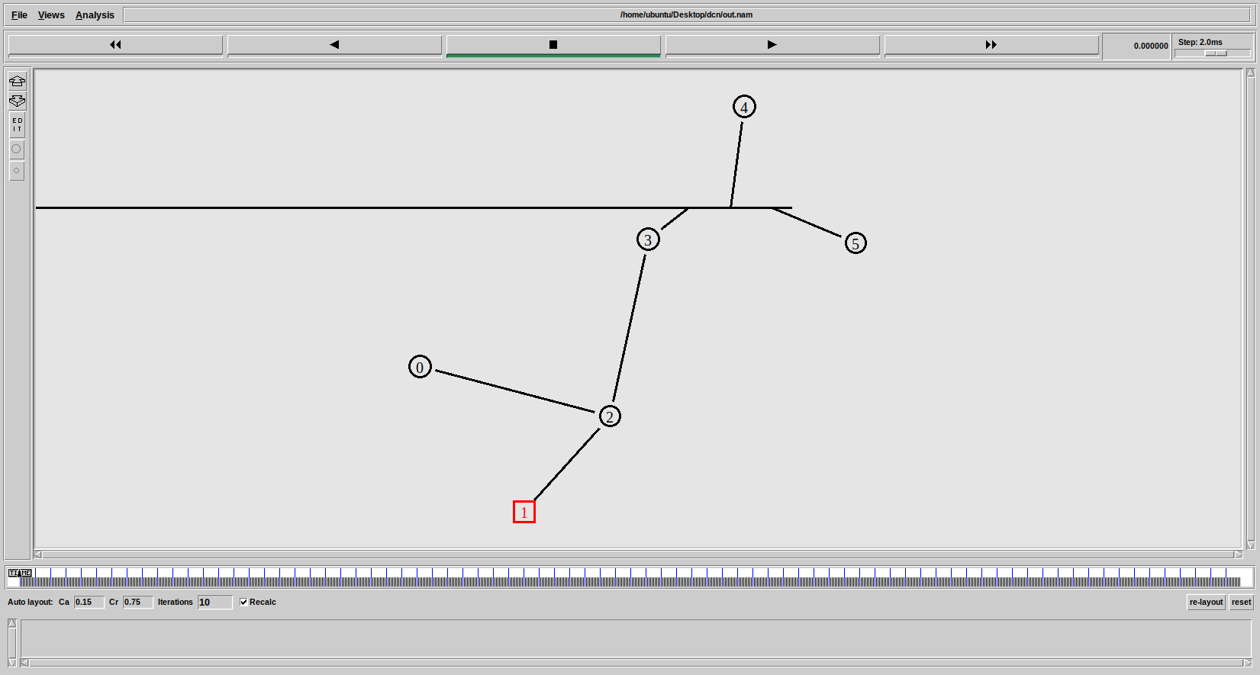

Figure 15 NAM Output: CSMA/CA

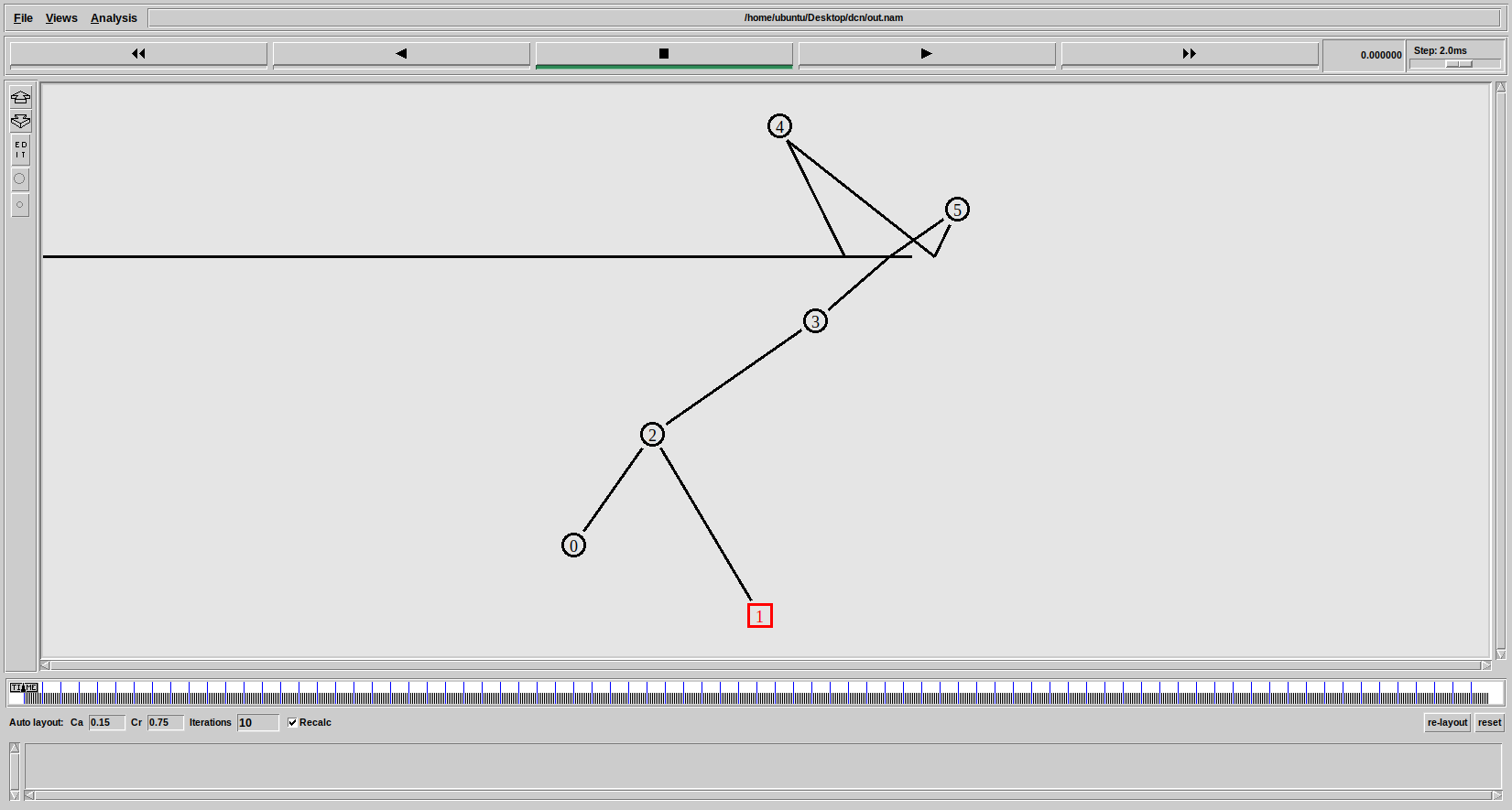

Figure 16 NAM Output: CSMA/CD

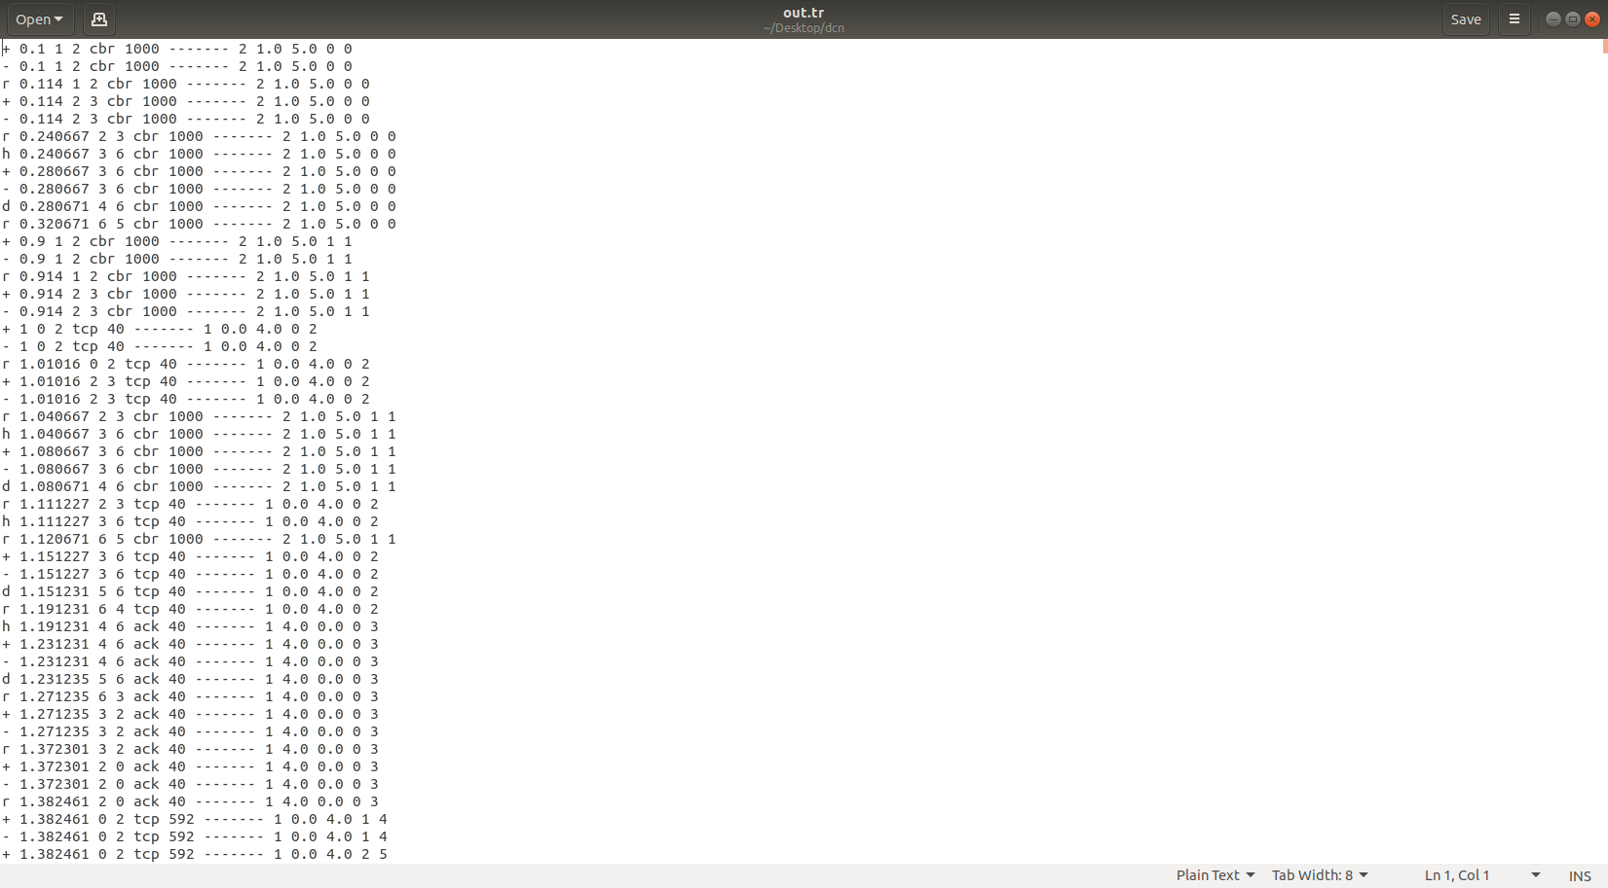

Figure 17 Tracefile : CSMA/CA

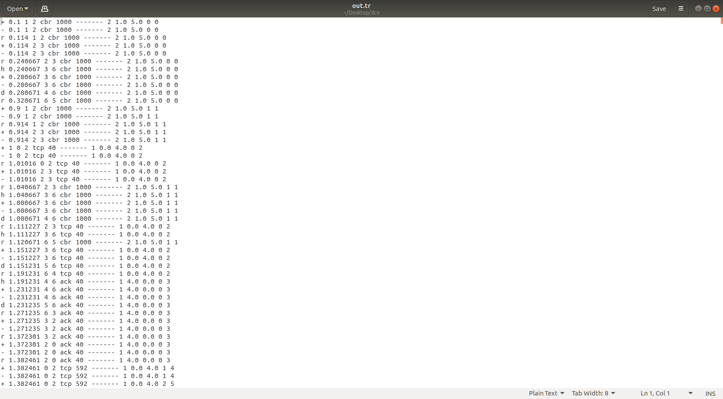

Figure 18 Tracefile : CSMA/CD

**RESULT:**

Comparison of CSMA/CA and CSMA/CD Protocols is Done Using NS2 Software.

|  |  |
| --- | --- |
| **EXPERIMENT 7** | **IMPLEMENTATION OF A ROUTING ALGORITHM** |

**AIM:** To Implement A Routing Algorithm And Observe The Network Performance Using NS2.

**APPARATUS:** Desktop PC

**SOFTWARE USED:** Network Simulator 2 (NS2)

**THEORY:**

Distance Vector Routing (DVR) Protocol is a method used by routers to find the best path for data to travel across a network. Each router keeps a table that shows the shortest distance to every other router, based on the number of hops (or steps) needed to reach them. Routers share this information with their neighbors, allowing them to update their tables and find the most efficient routes. This protocol helps ensure that data moves quickly and smoothly through the network.

The protocol requires that a router inform its neighbors of topology changes periodically. Historically known as the old ARPANET routing algorithm (or known as the Bellman-Ford algorithm). Each router maintains a Distance Vector table containing the distance between itself and all possible destination nodes. Distances, based on a chosen metric, are computed using information from the neighbors’ distance vectors.

The DV calculation is based on minimizing the cost to each destination

Dx(y) = Estimate of least cost from x to y

C(x,v) = Node x knows cost to each neighbor v

Dx = [Dx(y): y ? N ] = Node x maintains distance vector

Node x also maintains its neighbors' distance vectors

– For each neighbor v, x maintains Dv = [Dv(y): y ? N ]

**PROGRAM:**

set ns [new Simulator]

set nr [open thro.tr w]

$ns trace-all $nr

set nf [open thro.nam w]

$ns namtrace-all $nf

proc finish { } {

global ns nr nf

$ns flush-trace

close $nf

close $nr

exec nam thro.nam &

exit 0

}

for { set i 0 } { $i < 12} { incr i 1 } {

set n($i) [$ns node]}

for {set i 0} {$i < 8} {incr i} {

$ns duplex-link $n($i) $n([expr $i+1]) 1Mb 10ms DropTail }

$ns duplex-link $n(0) $n(8) 1Mb 10ms DropTail

$ns duplex-link $n(1) $n(10) 1Mb 10ms DropTail

$ns duplex-link $n(0) $n(9) 1Mb 10ms DropTail

$ns duplex-link $n(9) $n(11) 1Mb 10ms DropTail

$ns duplex-link $n(10) $n(11) 1Mb 10ms DropTail

$ns duplex-link $n(11) $n(5) 1Mb 10ms DropTail

set udp0 [new Agent/UDP]

$ns attach-agent $n(0) $udp0

set cbr0 [new Application/Traffic/CBR]

$cbr0 set packetSize_ 500

$cbr0 set interval_ 0.005

$cbr0 attach-agent $udp0

set null0 [new Agent/Null]

$ns attach-agent $n(5) $null0

$ns connect $udp0 $null0

set udp1 [new Agent/UDP]

$ns attach-agent $n(1) $udp1

set cbr1 [new Application/Traffic/CBR]

$cbr1 set packetSize_ 500

$cbr1 set interval_ 0.005

$cbr1 attach-agent $udp1

set null0 [new Agent/Null]

$ns attach-agent $n(5) $null0

$ns connect $udp1 $null0

$ns rtproto DV

$ns rtmodel-at 10.0 down $n(11) $n(5)

$ns rtmodel-at 15.0 down $n(7) $n(6)

$ns rtmodel-at 30.0 up $n(11) $n(5)

$ns rtmodel-at 20.0 up $n(7) $n(6)

$udp0 set fid_ 1

$udp1 set fid_ 2

$ns color 1 Red

$ns color 2 Green

$ns at 1.0 "$cbr0 start"

$ns at 2.0 "$cbr1 start"

$ns at 45 "finish"

$ns run

**PROCEDURE:**

* Turn The Pc On And Log Into Your Account. Linux OS Is Needed To Run NS2.
* Navigate To Your Directory.
* Open A Terminal Window In The Directory And Enter The Following Commands To Enter And Save The Code.

gedit exp7.tcl

* A Text Editor Window Is Opened. Enter Your Script And Save The File.
* Now, Enter The Following Command To Run The Simulation.

ns exp7.tcl

* A NAM Window Will Be Opened Displaying The Network Model. Observe The Behavior Of The Network.
* The Outputs Are Observed And Readings Are Noted Down.

**OUTPUTS:**

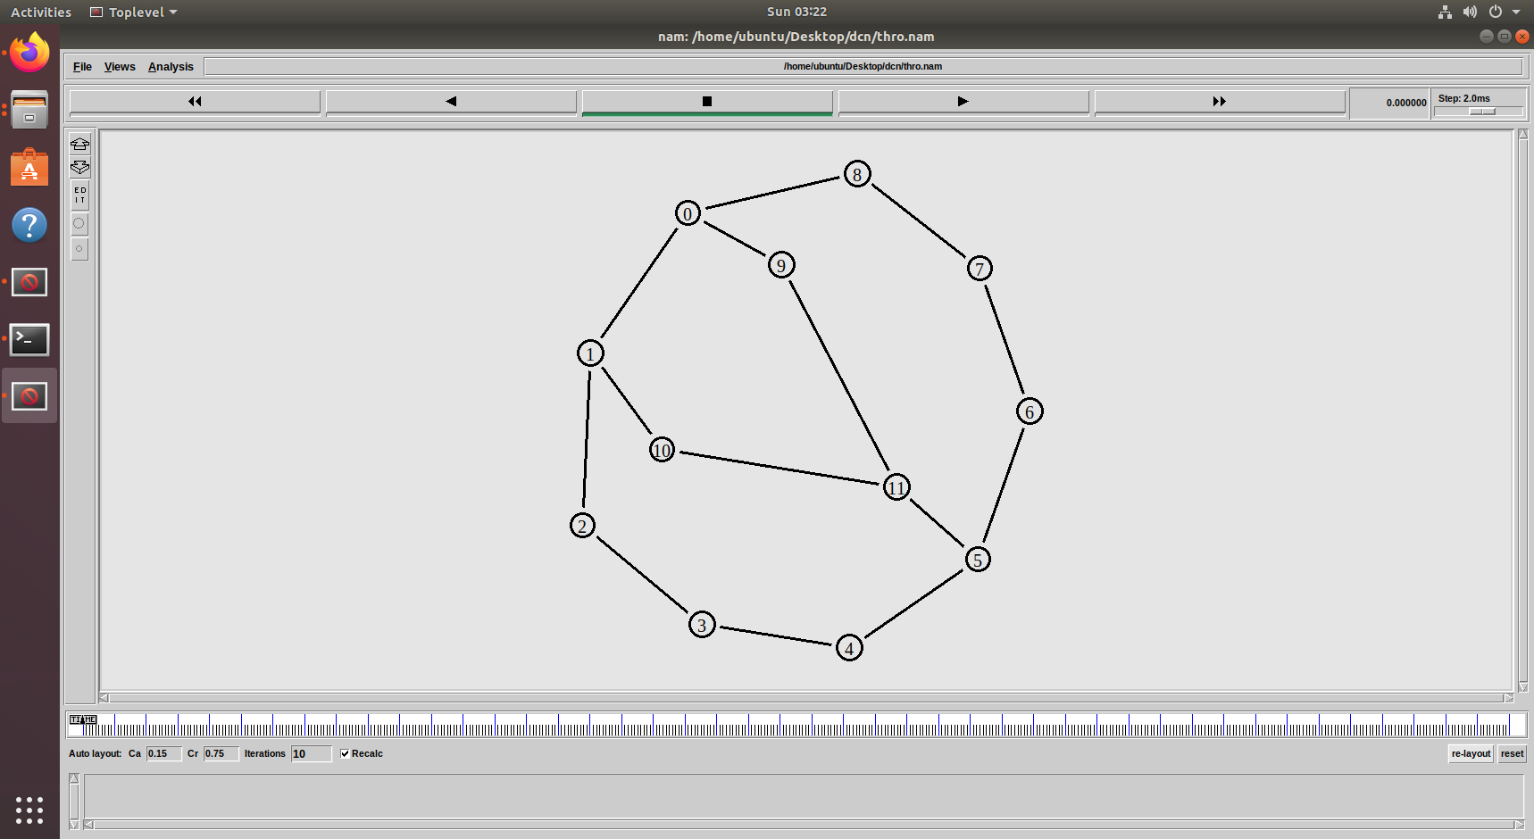

Figure 19 NAM Output

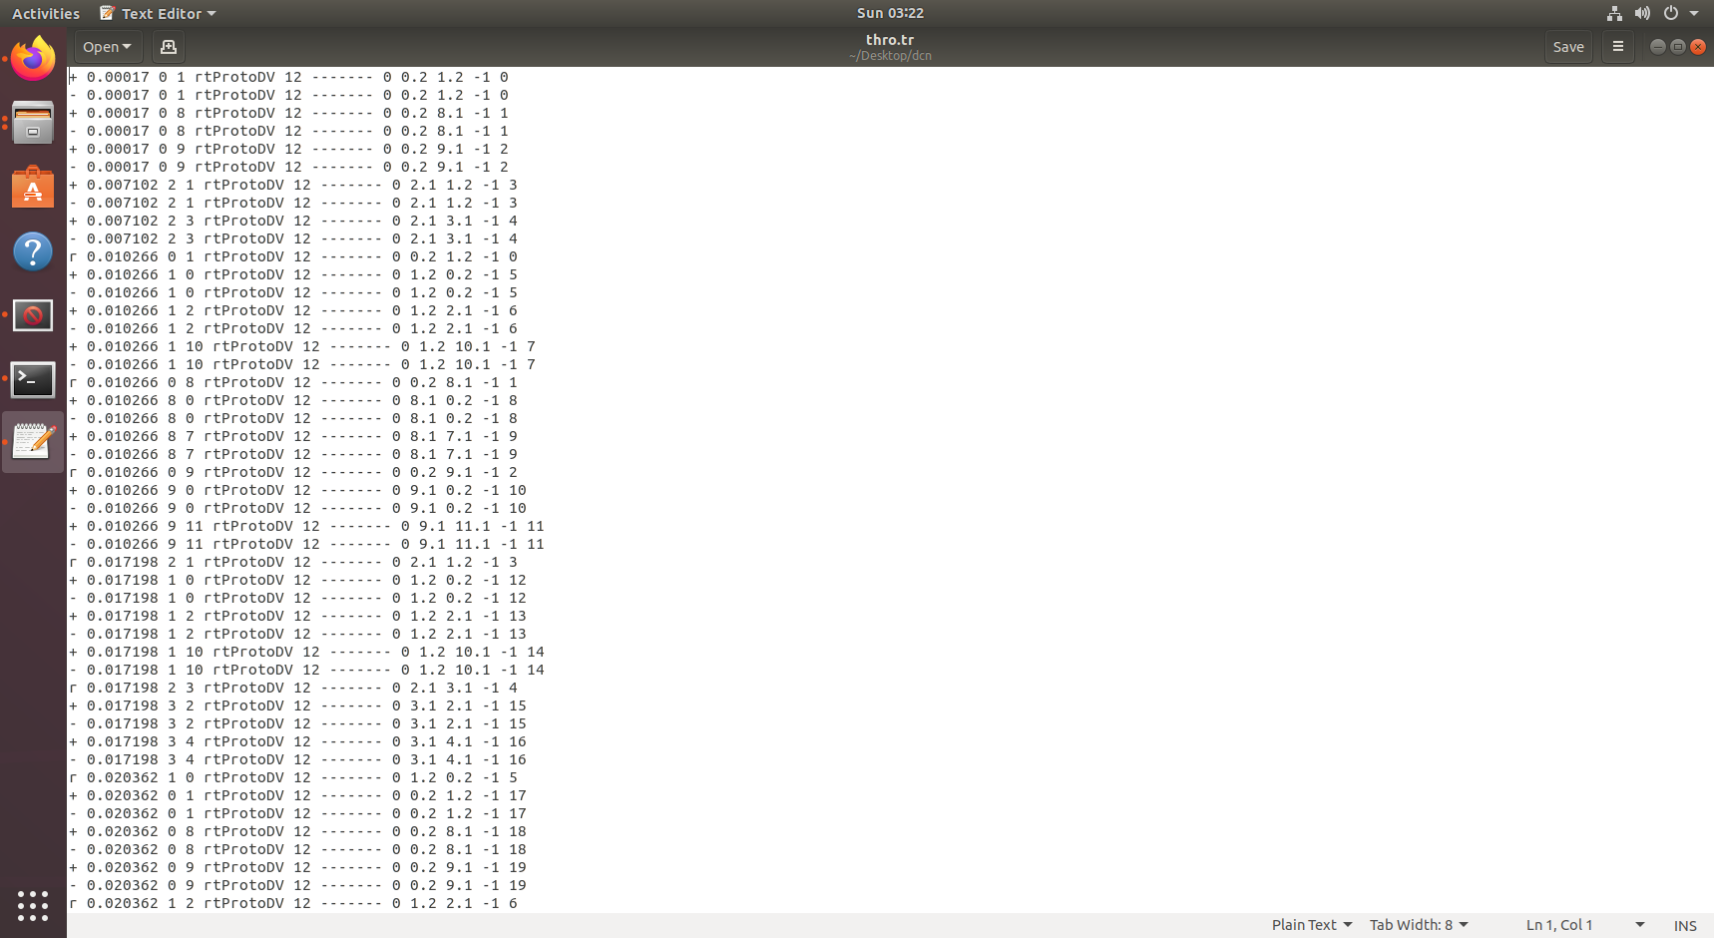

Figure 20 Tracefile Output

**RESULT:**

Distance Vector Routing Algorithm is Simulated and Observed Using NS2 Software.

|  |  |
| --- | --- |
| **EXPERIMENT 8** | **SIMULATION OF CONGESTION CONTROL ALGORITHMS** |

**AIM:** To Simulate Congestion Control Algorithms And Observe The Network Performance Using NS2.

**APPARATUS:** Desktop PC

**SOFTWARE USED:** Network Simulator 2 (NS2)

**THEORY:**

**Congestion Control** is a network layer mechanism that controls the data flow between a source and a destination to prevent network congestion. When network congestion occurs, packet loss increases, delay increases, and the overall network performance degrades. To avoid or control congestion, several congestion control algorithms are implemented.

In **TCP (Transmission Control Protocol)**, the most widely used transport layer protocol, employs various congestion control algorithms to ensure smooth data transmission.

The three most popular TCP congestion control algorithms are:

**TCP Reno**, **TCP NewReno**, **TCP Vegas**

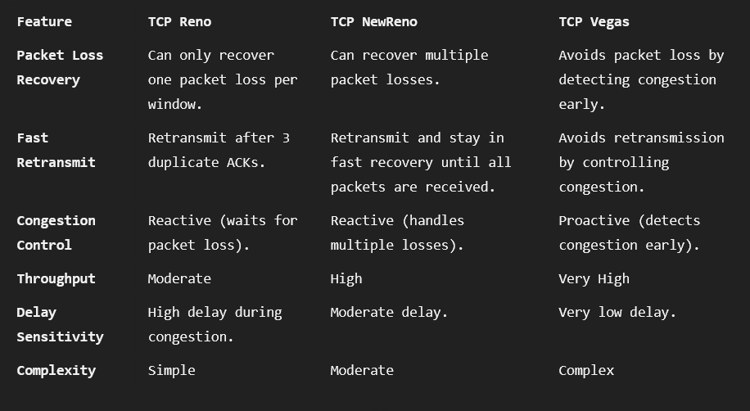

**PROGRAM: RENO:**

#Create a simulator object

set ns [new Simulator]

#Open the nam file basic1.nam and the variable-trace file basic1.tr

set namfile [open congestion.nam w]

$ns namtrace-all $namfile

set tracefile [open congestion.tr w]

$ns trace-all $tracefile

#Define a 'finish' procedure

proc finish {} {

global ns nf

$ns flush-trace

# Execute NAM on the trace file

exec nam congestion.nam &

exit 0

}

#Create the network nodes

set n0 [$ns node]

set n1 [$ns node]

set n2 [$ns node]

set n3 [$ns node]

#Create a duplex link between the nodes

$ns duplex-link $n0 $n1 1Mb 10ms DropTail

$ns duplex-link $n1 $n2 1.5Mb 50ms RED

$ns duplex-link $n3 $n0 2Mb 50ms DropTail

# The queue size at $R is to be 7, including the packet being sent

$ns queue-limit $n0 $n1 10

$ns queue-limit $n1 $n2 15

$ns queue-limit $n3 $n0 20

# Create a TCP sending agent and attach it to A

set tcp0 [new Agent/TCP/Reno]

# We make our one-and-only flow be flow 0

$tcp0 set class_ 0

$tcp0 set window_ 100

$tcp0 set packetSize_ 960

$ns attach-agent $n0 $tcp0

# Let's trace some variables

$tcp0 attach $tracefile

$tcp0 tracevar cwnd_

$tcp0 tracevar ssthresh_

$tcp0 tracevar ack_

$tcp0 tracevar maxseq_

#Create a TCP receive agent (a traffic sink) and attach it to B

set end0 [new Agent/TCPSink]

$ns attach-agent $n1 $end0

#Connect the traffic source with the traffic sink

$ns connect $tcp0 $end0

#Schedule the connection data flow; start sending data at T=0, stop at T=10.0

set myftp [new Application/FTP]

$myftp attach-agent $tcp0

$ns at 0.0 "$myftp start"

$ns at 10.0 "finish"

#Run the simulation

$ns run

**PROGRAM: NEWRENO:**

#Create a simulator object

set ns [new Simulator]

#Open the nam file basic1.nam and the variable-trace file basic1.tr

set namfile [open congestion.nam w]

$ns namtrace-all $namfile

set tracefile [open congestion.tr w]

$ns trace-all $tracefile

#Define a 'finish' procedure

proc finish {} {

global ns nf

$ns flush-trace

# Execute NAM on the trace file

exec nam congestion.nam &

exit 0

}

#Create the network nodes

set n0 [$ns node]

set n1 [$ns node]

set n2 [$ns node]

set n3 [$ns node]

#Create a duplex link between the nodes

$ns duplex-link $n0 $n1 1Mb 10ms DropTail

$ns duplex-link $n1 $n2 1.5Mb 50ms DropTail

$ns duplex-link $n3 $n0 2Mb 50ms DropTail

# The queue size at $R is to be 7, including the packet being sent

$ns queue-limit $n0 $n1 10

$ns queue-limit $n1 $n2 15

$ns queue-limit $n3 $n0 20

# Create a TCP sending agent and attach it to A

set tcp0 [new Agent/TCP/Newreno]

# We make our one-and-only flow be flow 0

$tcp0 set class_ 0

$tcp0 set window_ 100

$tcp0 set packetSize_ 960

$ns attach-agent $n0 $tcp0

# Let's trace some variables

$tcp0 attach $tracefile

$tcp0 tracevar cwnd_

$tcp0 tracevar ssthresh_

$tcp0 tracevar ack_

$tcp0 tracevar maxseq_

#Create a TCP receive agent (a traffic sink) and attach it to B

set end0 [new Agent/TCPSink]

$ns attach-agent $n1 $end0

#Connect the traffic source with the traffic sink

$ns connect $tcp0 $end0

#Schedule the connection data flow; start sending data at T=0, stop at T=10.0

set myftp [new Application/FTP]

$myftp attach-agent $tcp0

$ns at 0.0 "$myftp start"

$ns at 10.0 "finish"

#Run the simulation

$ns run

**PROGRAM: VEGAS:**

#Create a simulator object

set ns [new Simulator]

#Open the nam file basic1.nam and the variable-trace file basic1.tr

set namfile [open congestion.nam w]

$ns namtrace-all $namfile

set tracefile [open congestion.tr w]

$ns trace-all $tracefile

#Define a 'finish' procedure

proc finish {} {

global ns nf

$ns flush-trace

# Execute NAM on the trace file

exec nam congestion.nam &

exit 0

}

#Create the network nodes

set n0 [$ns node]

set n1 [$ns node]

set n2 [$ns node]

set n3 [$ns node]

#Create a duplex link between the nodes

$ns duplex-link $n0 $n1 1Mb 10ms DropTail

$ns duplex-link $n1 $n2 1.5Mb 50ms DropTail

$ns duplex-link $n3 $n0 2Mb 50ms DropTail

# The queue size at $R is to be 7, including the packet being sent

$ns queue-limit $n0 $n1 10

$ns queue-limit $n1 $n2 15

$ns queue-limit $n3 $n0 20

# Create a TCP sending agent and attach it to A

set tcp0 [new Agent/TCP/Vegas]

# We make our one-and-only flow be flow 0

$tcp0 set class_ 0

$tcp0 set window_ 100

$tcp0 set packetSize_ 960

$ns attach-agent $n0 $tcp0

# Let's trace some variables

$tcp0 attach $tracefile

$tcp0 tracevar cwnd_

$tcp0 tracevar ssthresh_

$tcp0 tracevar ack_

$tcp0 tracevar maxseq_

#Create a TCP receive agent (a traffic sink) and attach it to B

set end0 [new Agent/TCPSink]

$ns attach-agent $n1 $end0

#Connect the traffic source with the traffic sink

$ns connect $tcp0 $end0

#Schedule the connection data flow; start sending data at T=0, stop at T=10.0

set myftp [new Application/FTP]

$myftp attach-agent $tcp0

$ns at 0.0 "$myftp start"

$ns at 10.0 "finish"

#Run the simulation

$ns run

**PROCEDURE:**

* Turn The Pc On And Log Into Your Account. Linux OS Is Needed To Run NS2.
* Navigate To Your Directory.
* Open A Terminal Window In The Directory And Enter The Following Commands To Enter And Save The Code.

gedit exp8.tcl

* A Text Editor Window Is Opened. Enter Your Script And Save The File.
* Now, Enter The Following Command To Run The Simulation.

ns exp8.tcl

* A NAM Window Will Be Opened Displaying The Network Model. Observe The Behavior Of The Network.
* For Further Analysis We Need .Awk Script Files. Copy These Files To The Same Folder As The NS2 Script.
* The .awk Files Can Be Executed By Using The Following Command:

awk –f analyze.awk tracefile.tr

* The Outputs Are Observed And Readings Are Noted Down.

**OUTPUTS:**

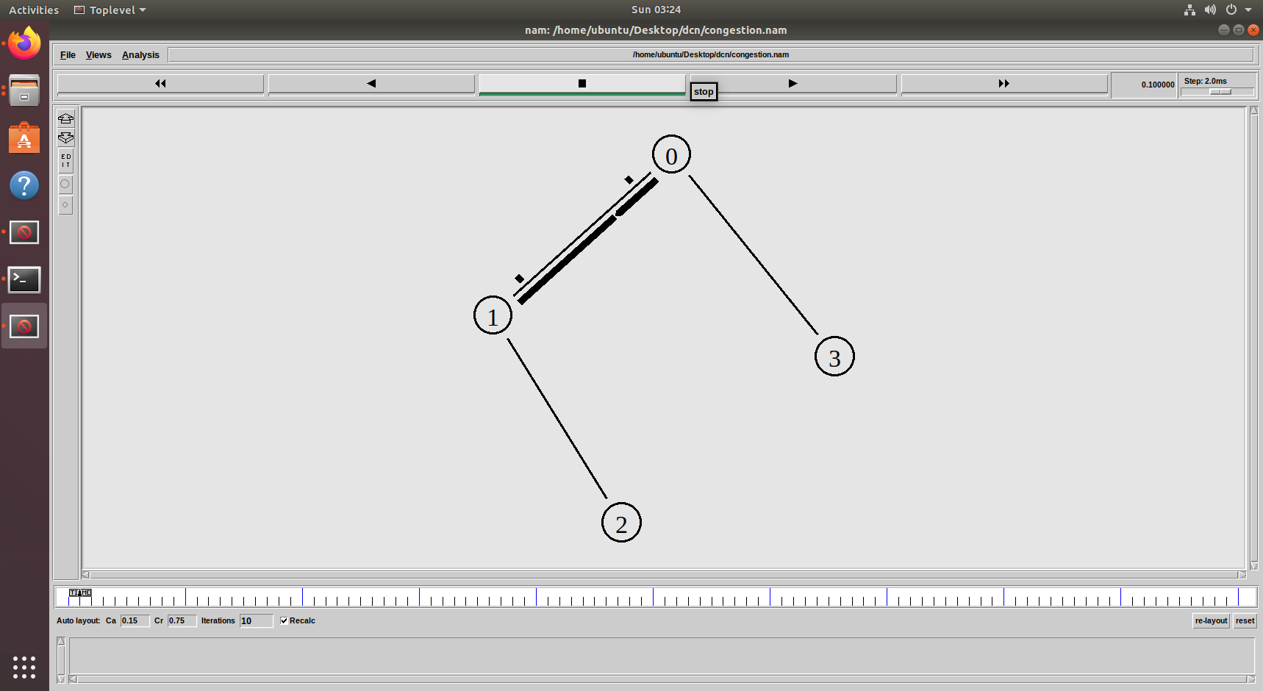

Figure 21 NAM Output

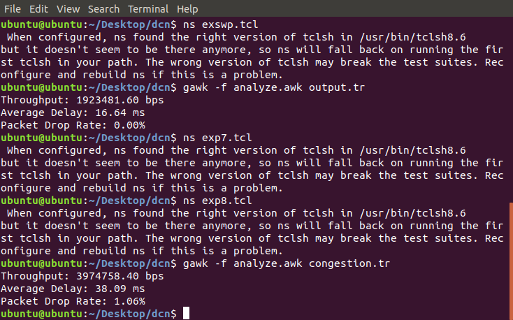

Figure 22 Reno Awk Output

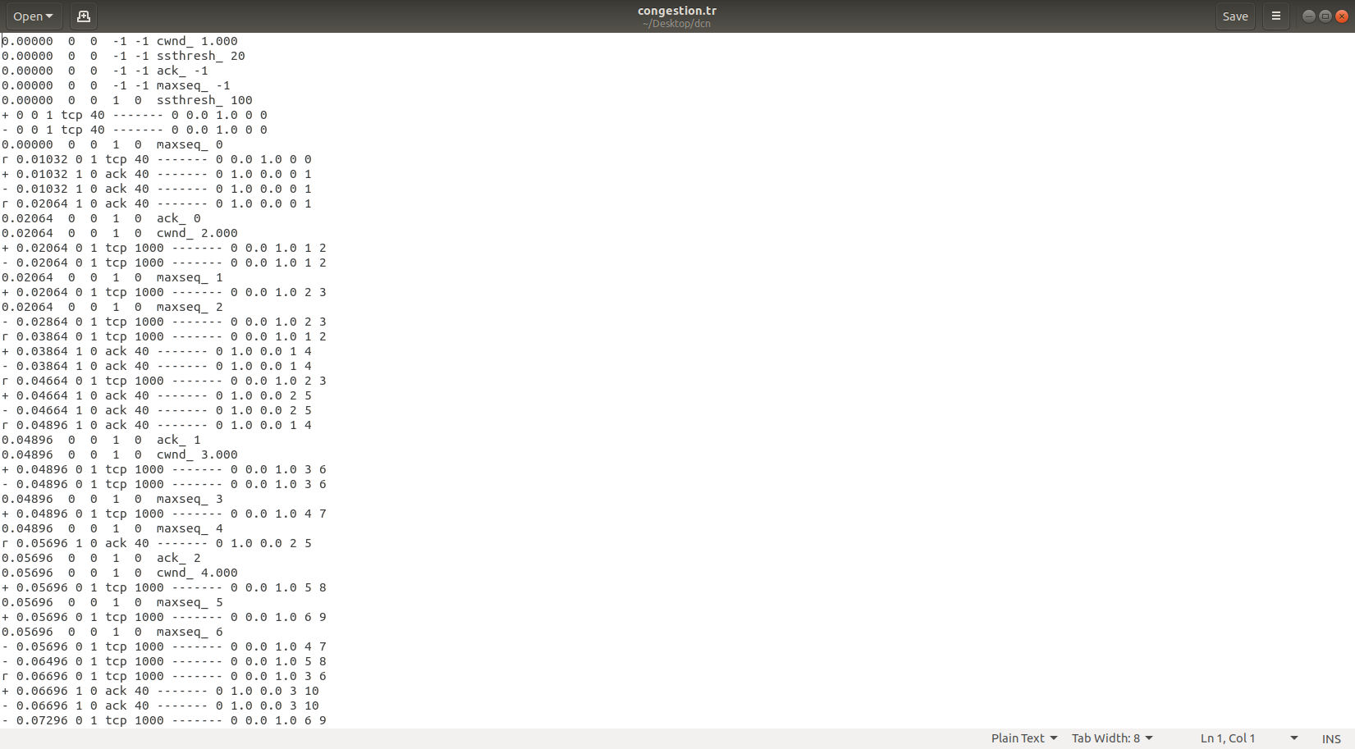

Figure 23 Reno Tracefile

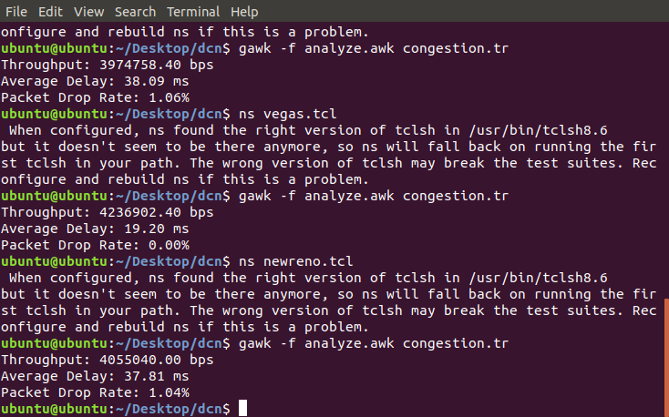

Figure 24 New Reno Awk Output

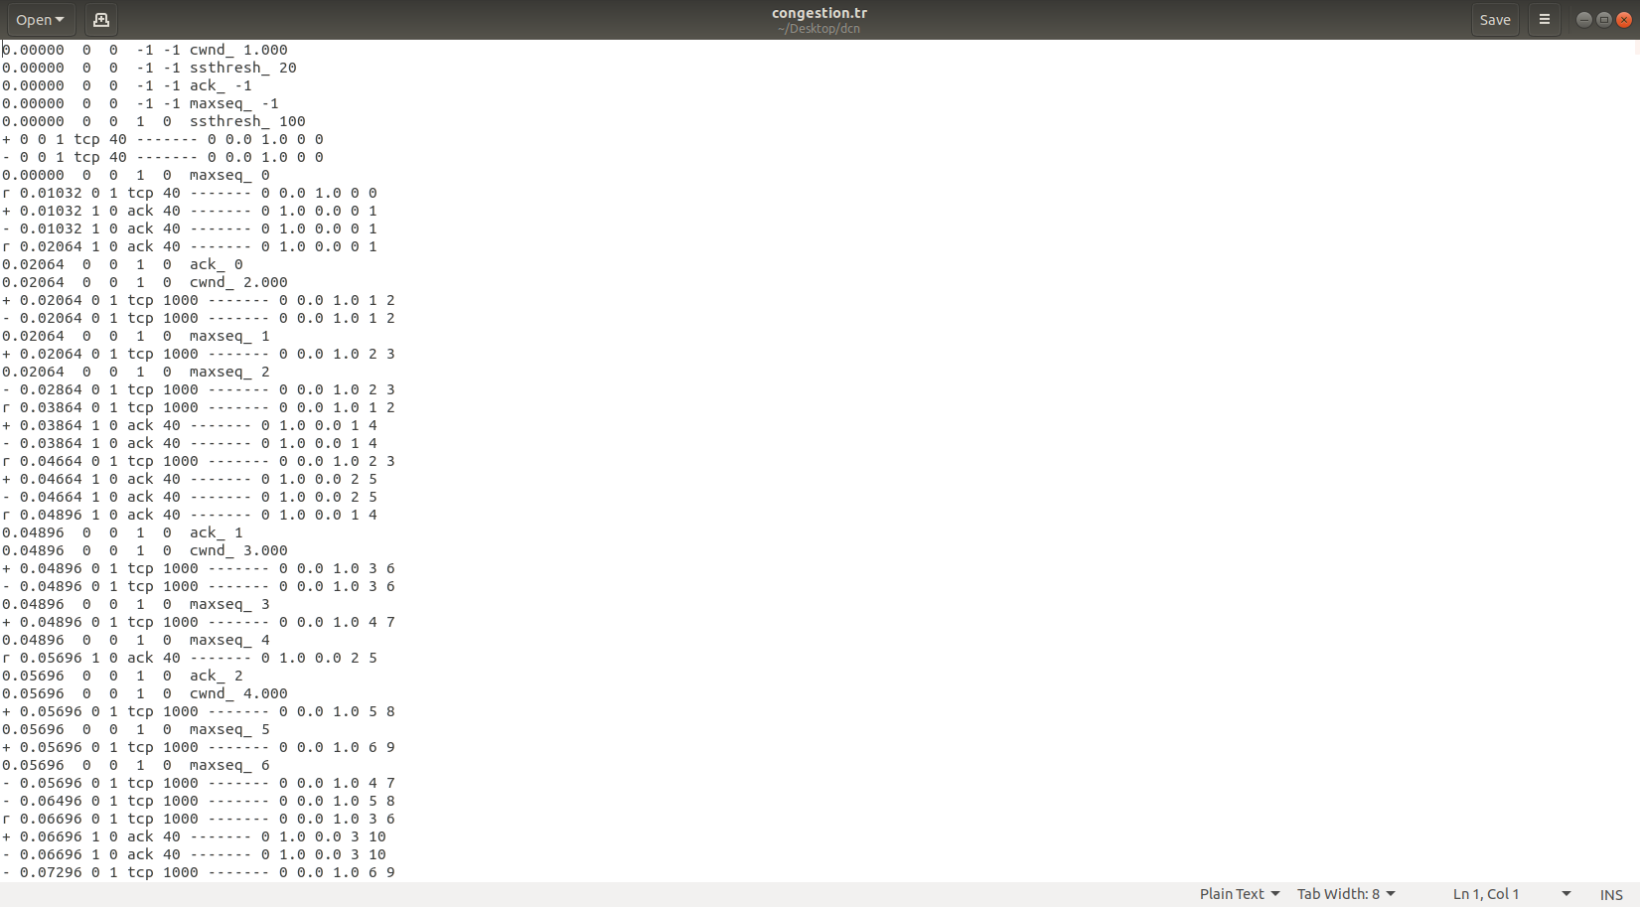

Figure 25 New Reno Tracefile

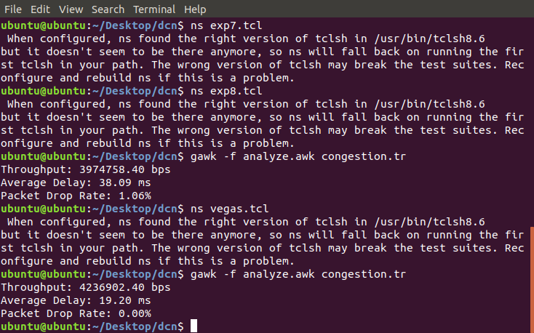

Figure 26 Vegas Awk Output

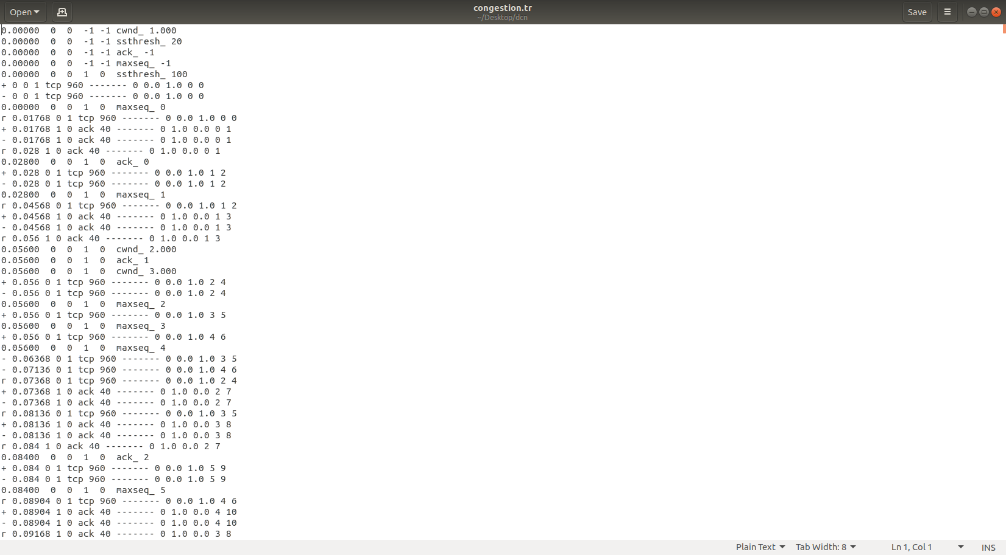

Figure 27 Vegas Tracefile

**RESULT:**

Simulation and Comparison of Congestion Control Algorithms (Reno, New Reno, Vegas) is Done Using NS2 Software.

|  |  |
| --- | --- |
| **EXPERIMENT 9** | **SIMULATION OF DIFFERENT LAN TOPOLOGIES** |

**AIM:** To Simulate and Compare Different LAN Topologies.

**APPARATUS:** Desktop PC

**SOFTWARE USED:** Network Simulator 2 (NS2)

**THEORY:**

**LAN Topologies**

1. **Star Topology:**
   * **All devices** are connected to a **central hub/switch**.
   * **Pros:** Easy to install, failure of one device doesn’t affect others.
   * **Cons:** Failure of hub can down the network.
   * **Example:** Home/Office networks.
2. **Mesh Topology:**
   * Every device is **directly connected** to others.
   * **Pros:** Highly reliable, multiple data paths.
   * **Cons:** Expensive, complex to maintain.
   * **Example:** Data centers, military networks.
3. **Bus Topology:**
   * All devices share a **single central cable (bus)**.
   * **Pros:** Easy setup, low cost.
   * **Cons:** Cable failure affects entire network.
   * **Example:** Small offices, early LANs.
4. **Ring Topology:**
   * Devices form a **closed loop (ring)**.
   * **Pros:** Simple setup, no central hub.
   * **Cons:** Failure of one device disrupts network.
   * **Example:** Token ring networks.

**PROGRAM: MESH:**

# Define simulator

set ns [new Simulator]

# Create trace and NAM files

set tracefile [open lan_trace.tr w]

$ns trace-all $tracefile

set namfile [open lan.nam w]

$ns namtrace-all $namfile

# Create network nodes

set n0 [$ns node]

set n1 [$ns node]

set n2 [$ns node]

set n3 [$ns node]

set n4 [$ns node]

set n5 [$ns node]

# Mesh Topology (Fully connected)

$ns duplex-link $n0 $n1 10Mb 10ms DropTail

$ns duplex-link $n0 $n2 10Mb 10ms DropTail

$ns duplex-link $n0 $n3 10Mb 10ms DropTail

$ns duplex-link $n0 $n4 10Mb 10ms DropTail

$ns duplex-link $n0 $n5 10Mb 10ms DropTail

$ns duplex-link $n1 $n2 10Mb 10ms DropTail

$ns duplex-link $n1 $n3 10Mb 10ms DropTail

$ns duplex-link $n1 $n4 10Mb 10ms DropTail

$ns duplex-link $n1 $n5 10Mb 10ms DropTail

$ns duplex-link $n2 $n3 10Mb 10ms DropTail

$ns duplex-link $n2 $n4 10Mb 10ms DropTail

$ns duplex-link $n2 $n5 10Mb 10ms DropTail

$ns duplex-link $n3 $n4 10Mb 10ms DropTail

$ns duplex-link $n3 $n5 10Mb 10ms DropTail

$ns duplex-link $n4 $n5 10Mb 10ms DropTail

# Create TCP connections for comparison

set tcp1 [new Agent/TCP]

$ns attach-agent $n1 $tcp1

set sink1 [new Agent/TCPSink]

$ns attach-agent $n3 $sink1

$ns connect $tcp1 $sink1

set tcp2 [new Agent/TCP]

$ns attach-agent $n2 $tcp2

set sink2 [new Agent/TCPSink]

$ns attach-agent $n4 $sink2

$ns connect $tcp2 $sink2

# Traffic Generation (CBR)

set cbr1 [new Application/Traffic/CBR]

$cbr1 set packetSize_ 500

$cbr1 set interval_ 0.01

$cbr1 attach-agent $tcp1

set cbr2 [new Application/Traffic/CBR]

$cbr2 set packetSize_ 500

$cbr2 set interval_ 0.01

$cbr2 attach-agent $tcp2

# Run simulation

$ns at 0.5 "$cbr1 start"

$ns at 1.0 "$cbr2 start"

$ns at 9.5 "$cbr1 stop"

$ns at 9.0 "$cbr2 stop"

$ns at 10.0 "finish"

proc finish {} {

global ns tracefile namfile

$ns flush-trace

close $tracefile

close $namfile

exec nam lan.nam &

exit 0

}

$ns run

**PROGRAM: STAR:**

# Define simulator

set ns [new Simulator]

# Create trace and NAM files

set tracefile [open lan_trace.tr w]

$ns trace-all $tracefile

set namfile [open lan.nam w]

$ns namtrace-all $namfile

# Create network nodes

set n0 [$ns node]

set n1 [$ns node]

set n2 [$ns node]

set n3 [$ns node]

set n4 [$ns node]

set n5 [$ns node]

# Mesh Topology (Fully connected)

$ns duplex-link $n0 $n1 10Mb 10ms DropTail

$ns duplex-link $n0 $n2 10Mb 10ms DropTail

$ns duplex-link $n0 $n3 10Mb 10ms DropTail

$ns duplex-link $n0 $n4 10Mb 10ms DropTail

$ns duplex-link $n0 $n5 10Mb 10ms DropTail

# Create TCP connections for comparison

set tcp1 [new Agent/TCP]

$ns attach-agent $n1 $tcp1

set sink1 [new Agent/TCPSink]

$ns attach-agent $n3 $sink1

$ns connect $tcp1 $sink1

set tcp2 [new Agent/TCP]

$ns attach-agent $n2 $tcp2

set sink2 [new Agent/TCPSink]

$ns attach-agent $n4 $sink2

$ns connect $tcp2 $sink2

# Traffic Generation (CBR)

set cbr1 [new Application/Traffic/CBR]

$cbr1 set packetSize_ 500

$cbr1 set interval_ 0.01

$cbr1 attach-agent $tcp1

set cbr2 [new Application/Traffic/CBR]

$cbr2 set packetSize_ 500

$cbr2 set interval_ 0.01

$cbr2 attach-agent $tcp2

# Run simulation

$ns at 0.5 "$cbr1 start"

$ns at 1.0 "$cbr2 start"

$ns at 9.5 "$cbr1 stop"

$ns at 9.0 "$cbr2 stop"

$ns at 10.0 "finish"

proc finish {} {

global ns tracefile namfile

$ns flush-trace

close $tracefile

close $namfile

exec nam lan.nam &

exit 0

}

$ns run

**PROGRAM: BUS:**

# Define simulator

set ns [new Simulator]

# Create trace and NAM files

set tracefile [open lan_trace.tr w]

$ns trace-all $tracefile

set namfile [open lan.nam w]

$ns namtrace-all $namfile

# Create network nodes

set n0 [$ns node]

set n1 [$ns node]

set n2 [$ns node]

set n3 [$ns node]

set n4 [$ns node]

set n5 [$ns node]

# Mesh Topology (Fully connected)

$ns duplex-link $n0 $n1 10Mb 10ms DropTail

$ns duplex-link $n1 $n2 10Mb 10ms DropTail

$ns duplex-link $n2 $n3 10Mb 10ms DropTail

$ns duplex-link $n3 $n4 10Mb 10ms DropTail

$ns duplex-link $n4 $n5 10Mb 10ms DropTail

# Create TCP connections for comparison

set tcp1 [new Agent/TCP]

$ns attach-agent $n1 $tcp1

set sink1 [new Agent/TCPSink]

$ns attach-agent $n3 $sink1

$ns connect $tcp1 $sink1

set tcp2 [new Agent/TCP]

$ns attach-agent $n2 $tcp2

set sink2 [new Agent/TCPSink]

$ns attach-agent $n4 $sink2

$ns connect $tcp2 $sink2

# Traffic Generation (CBR)

set cbr1 [new Application/Traffic/CBR]

$cbr1 set packetSize_ 500

$cbr1 set interval_ 0.01

$cbr1 attach-agent $tcp1

set cbr2 [new Application/Traffic/CBR]

$cbr2 set packetSize_ 500

$cbr2 set interval_ 0.01

$cbr2 attach-agent $tcp2

# Run simulation

$ns at 0.5 "$cbr1 start"

$ns at 1.0 "$cbr2 start"

$ns at 9.5 "$cbr1 stop"

$ns at 9.0 "$cbr2 stop"

$ns at 10.0 "finish"

proc finish {} {

global ns tracefile namfile

$ns flush-trace

close $tracefile

close $namfile

exec nam lan.nam &

exit 0 }

$ns run

**PROGRAM: RING:**

# Define simulator

set ns [new Simulator]

# Create trace and NAM files

set tracefile [open lan_trace.tr w]

$ns trace-all $tracefile

set namfile [open lan.nam w]

$ns namtrace-all $namfile

# Create network nodes

set n0 [$ns node]

set n1 [$ns node]

set n2 [$ns node]

set n3 [$ns node]

set n4 [$ns node]

set n5 [$ns node]

# Mesh Topology (Fully connected)

$ns duplex-link $n0 $n1 10Mb 10ms DropTail

$ns duplex-link $n1 $n2 10Mb 10ms DropTail

$ns duplex-link $n2 $n3 10Mb 10ms DropTail

$ns duplex-link $n3 $n4 10Mb 10ms DropTail

$ns duplex-link $n4 $n5 10Mb 10ms DropTail

$ns duplex-link $n5 $n0 10Mb 10ms DropTail

# Create TCP connections for comparison

set tcp1 [new Agent/TCP]

$ns attach-agent $n1 $tcp1

set sink1 [new Agent/TCPSink]

$ns attach-agent $n3 $sink1

$ns connect $tcp1 $sink1

set tcp2 [new Agent/TCP]

$ns attach-agent $n2 $tcp2

set sink2 [new Agent/TCPSink]

$ns attach-agent $n4 $sink2

$ns connect $tcp2 $sink2

# Traffic Generation (CBR)

set cbr1 [new Application/Traffic/CBR]

$cbr1 set packetSize_ 500

$cbr1 set interval_ 0.01

$cbr1 attach-agent $tcp1

set cbr2 [new Application/Traffic/CBR]

$cbr2 set packetSize_ 500

$cbr2 set interval_ 0.01

$cbr2 attach-agent $tcp2

# Run simulation

$ns at 0.5 "$cbr1 start"

$ns at 1.0 "$cbr2 start"

$ns at 9.5 "$cbr1 stop"

$ns at 9.0 "$cbr2 stop"

$ns at 10.0 "finish"

proc finish {} {

global ns tracefile namfile

$ns flush-trace

close $tracefile

close $namfile

exec nam lan.nam &

exit 0 }

$ns run

**ANALYZE.AWK:**

#!/usr/bin/awk -f

BEGIN {

start_time = -1;

end_time = 0;

received_packets = 0;

dropped_packets = 0;

total_delay = 0;

total_bytes = 0;

# Track connections

for (i = 0; i < 6; i++) {

for (j = 0; j < 6; j++) {

conn[i, j] = 0;

}

}

# Connection patterns for each topology

ring_connections_str = "0 1 1 2 2 3 3 4 4 5 5 0";

bus_connections_str = "0 1 1 2 2 3 3 4 4 5";

split(ring_connections_str, ring_connections, " ");

split(bus_connections_str, bus_connections, " ");

}

$1 == "s" {

if (start_time == -1) start_time = $2;

conn[$3, $4]++;

conn[$4, $3]++;

}

$1 == "r" {

received_packets++;

total_delay += ($2 - $8);

total_bytes += $6;

end_time = $2;

}

$1 == "d" {

dropped_packets++;

}

END {

total_time = end_time - start_time;

throughput = (total_bytes * 8) / (total_time * 1000);

avg_delay = (received_packets > 0) ? (total_delay / received_packets) * 1000 : 0;

drop_rate = (received_packets + dropped_packets > 0) ? (dropped_packets / (received_packets + dropped_packets)) * 100 : 0;

printf("Throughput: %.2f kbps\n", throughput);

printf("Average Delay: %.2f ms\n", avg_delay);

printf("Packet Drop Rate: %.2f%%\n", drop_rate);

}

**PROCEDURE:**

* Turn The Pc On And Log Into Your Account. Linux OS Is Needed To Run NS2.
* Navigate To Your Directory.
* Open A Terminal Window In The Directory And Enter The Following Commands To Enter And Save The Code.

gedit exp9.tcl

* A Text Editor Window Is Opened. Enter Your Script And Save The File.
* Now, Enter The Following Command To Run The Simulation.

ns exp9.tcl

* A NAM Window Will Be Opened Displaying The Network Model. Observe The Behavior Of The Network.
* For Further Analysis We Need .Awk Script Files. Copy These Files To The Same Folder As The NS2 Script.
* The .awk Files Can Be Executed By Using The Following Command:

awk –f analyze.awk tracefile.tr

* The Outputs Are Observed And Readings Are Noted Down.

**OUTPUTS:**

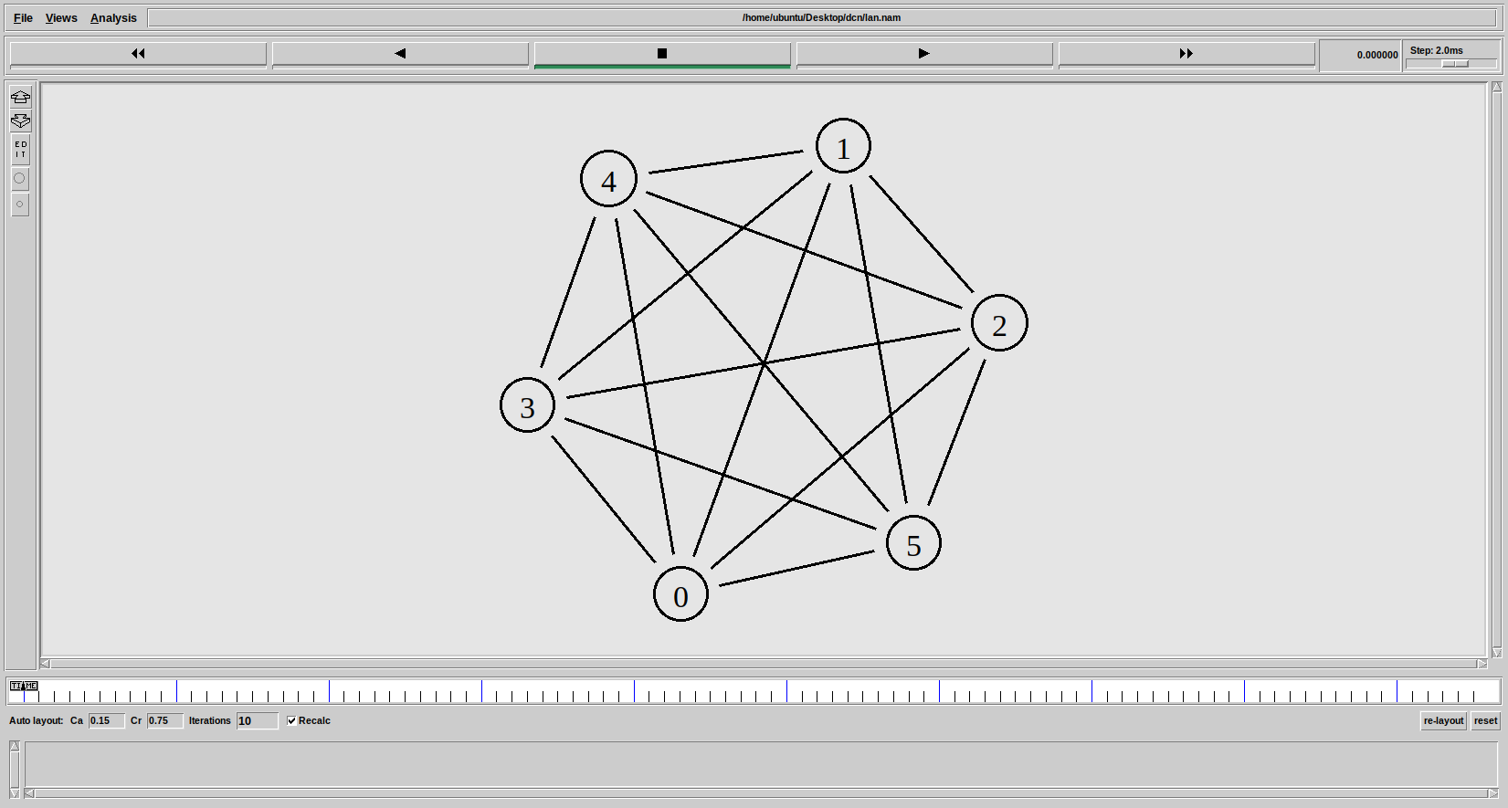

Figure 28 NAM Output Mesh Topology

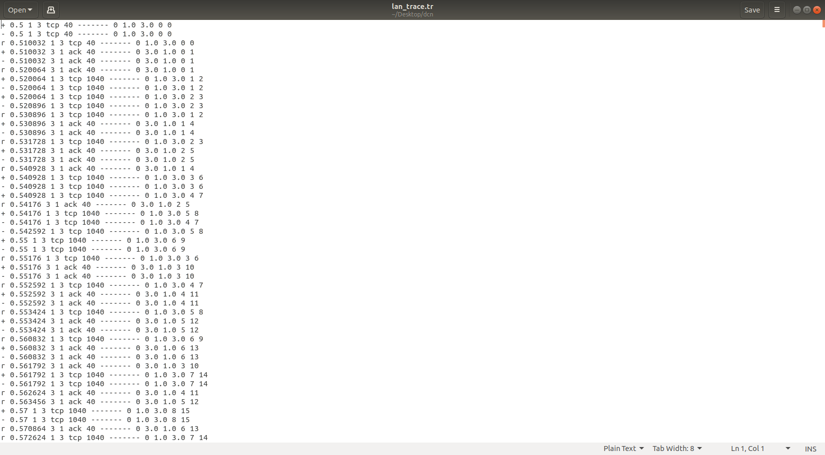

Figure 29 Tracefile: Mesh Topology

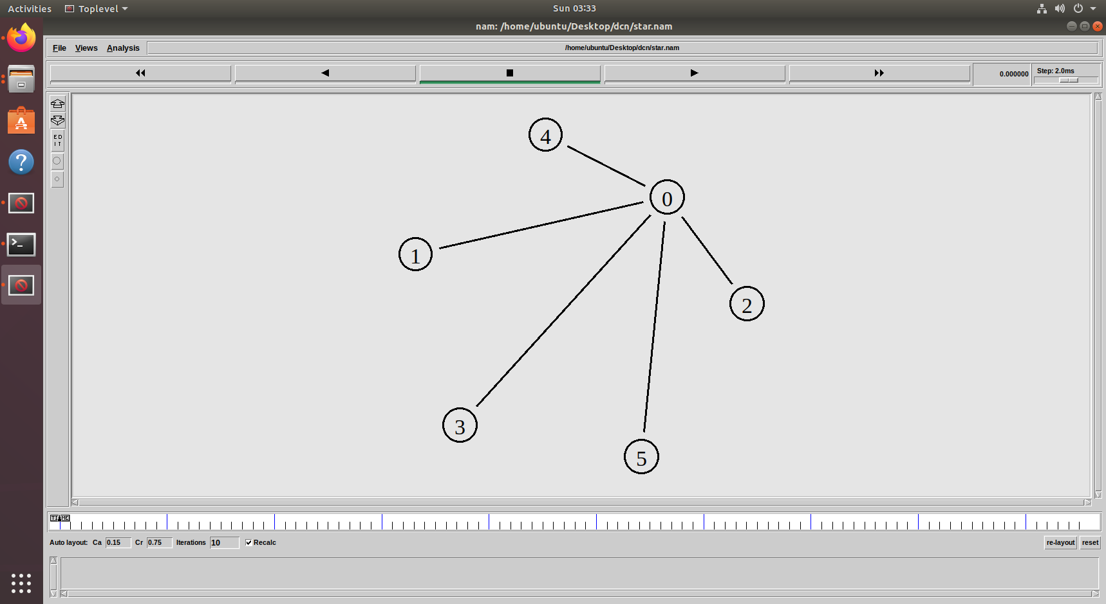

Figure 30 NAM Output : Star Topology

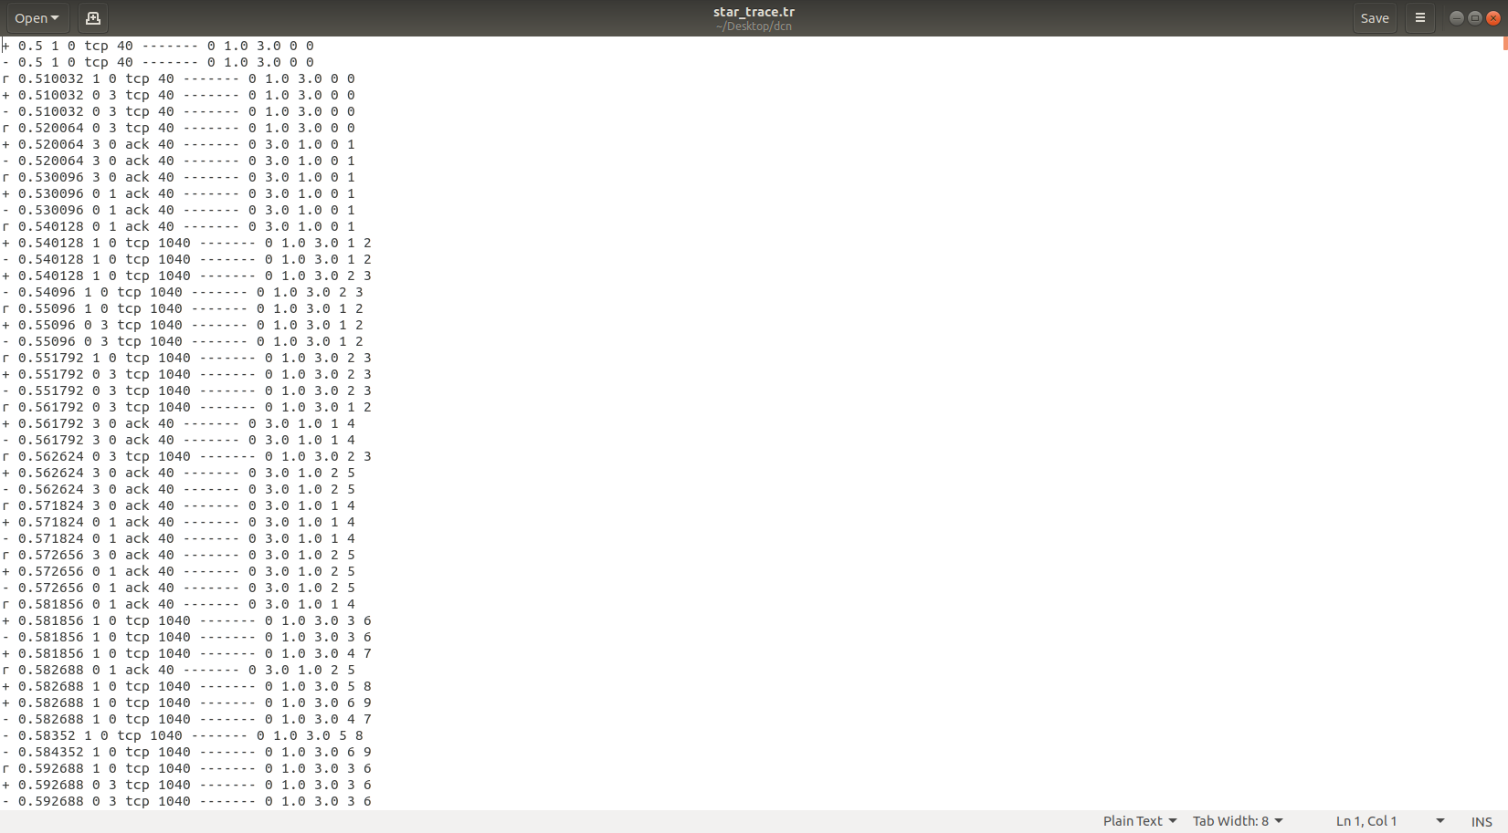

Figure 31 Tracefile : Star Topology

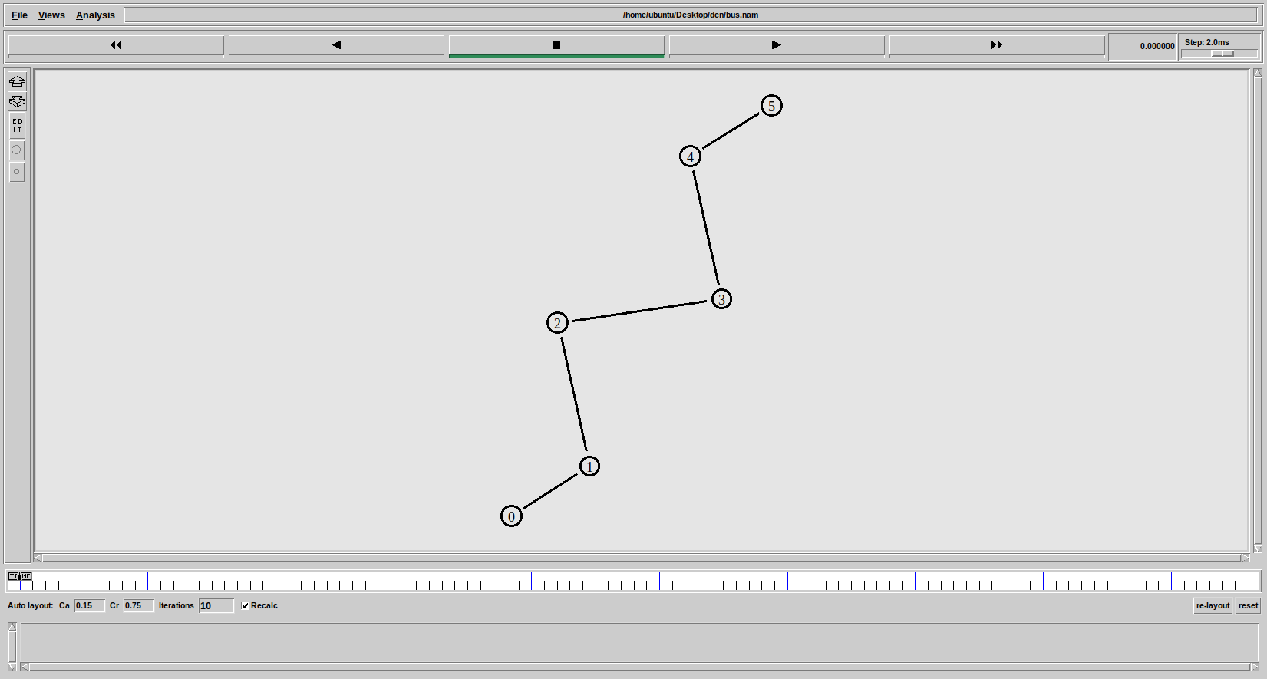

Figure 32 NAM Output : Bus Topology



Figure 33 Tracefile : Bus Topology

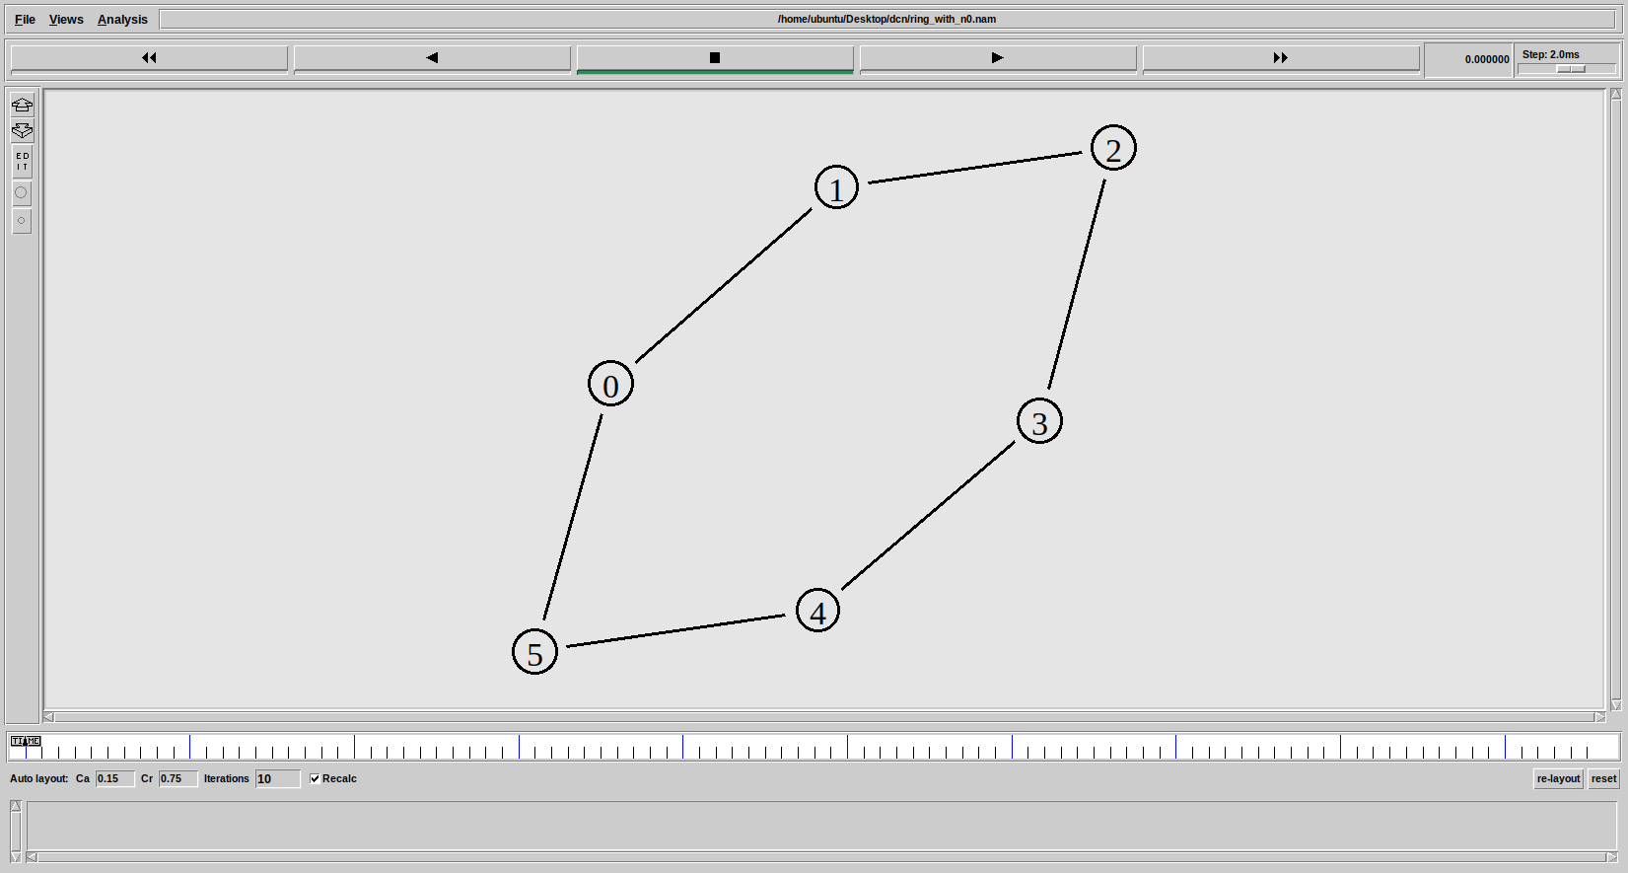

Figure 34 NAM Output : Ring Topology



Figure 35 Tracefile : Ring Topology

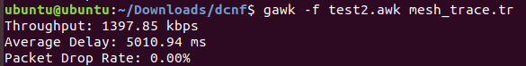

Figure 36 AWK Output Mesh

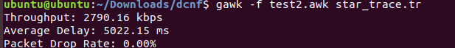

Figure 37 AWK Output Star

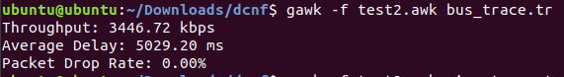

Figure 38 AWK Output Bus

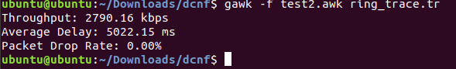

Figure 39 AWK Output Ring

**RESULT:**

Simulation and Comparison of Various LAN Topologies (Mesh, Star, Bus, Ring) is Done Using NS2 Software.

|  |  |
| --- | --- |
| **EXPERIMENT 10** | **INTERCONNECTING LANS USING SWITCH, HUB, ROUTER** |

**AIM:** To Interconnect LANs Using Switch, Hub, Router and Compare the Network Characteristics.

**APPARATUS:** Desktop PC

**SOFTWARE USED:** Network Simulator 2 (NS2)

**THEORY:**

A **Switch** is a network device used to connect multiple devices within a **Local Area Network (LAN)**. It operates at the **Data Link Layer (Layer 2)** and uses **MAC addresses** to forward data only to the intended device, reducing network congestion. Each port in a switch has its own **collision domain**, minimizing data collisions. Switches provide high-speed data transfer and are commonly used in offices and data centers.

A **Hub** is a basic network device that operates at the **Physical Layer (Layer 1)**. It simply broadcasts data to all devices connected, causing **data collisions** and reducing network efficiency. Hubs do not use **IP or MAC addresses**, making them less efficient. They are generally used in small networks with fewer devices due to their low cost and simple functionality.

A **Router** operates at the **Network Layer (Layer 3)** and connects different networks, such as **LAN to WAN or internet**. It uses **IP addresses** to route data between networks and creates separate **broadcast domains**, ensuring efficient traffic management. Routers provide **network security, fast data transfer**, and are widely used in homes, offices, and large networks.

**PROGRAM: SWITCH:**

# ring_switch.tcl

# Create a simulator object

set ns [new Simulator]

# Define trace file

set tracefile [open switch.tr w]

$ns trace-all $tracefile

# Define nam trace file

set namfile [open switch.nam w]

$ns namtrace-all $namfile

# Define finish procedure

proc finish {} {

global ns tracefile namfile

$ns flush-trace

close $tracefile

close $namfile

exec nam ring_switch.nam &

exit 0

}

# Create nodes for the first ring LAN

set ring1_n0 [$ns node]

set ring1_n1 [$ns node]

set ring1_n2 [$ns node]

set ring1_n3 [$ns node]

# Create nodes for the second ring LAN

set ring2_n4 [$ns node]

set ring2_n5 [$ns node]

set ring2_n6 [$ns node]

set ring2_n7 [$ns node]

# Create the switch

set switch [$ns node]

# Create links for the first ring LAN

$ns duplex-link $ring1_n0 $ring1_n1 10Mb 10ms DropTail

$ns duplex-link $ring1_n0 $ring1_n2 10Mb 10ms DropTail

$ns duplex-link $ring1_n0 $ring1_n3 10Mb 10ms DropTail

$ns duplex-link $ring1_n1 $ring1_n2 10Mb 10ms DropTail

$ns duplex-link $ring1_n1 $ring1_n3 10Mb 10ms DropTail

$ns duplex-link $ring1_n2 $ring1_n3 10Mb 10ms DropTail

# Create links for the second ring LAN

$ns duplex-link $ring2_n4 $ring2_n5 10Mb 10ms DropTail

$ns duplex-link $ring2_n5 $ring2_n6 10Mb 10ms DropTail

$ns duplex-link $ring2_n6 $ring2_n7 10Mb 10ms DropTail

$ns duplex-link $ring2_n7 $ring2_n4 10Mb 10ms DropTail

# Connect the ring LANs to the switch

$ns duplex-link $ring1_n3 $switch 10Mb 5ms DropTail

$ns duplex-link $switch $ring2_n4 10Mb 5ms DropTail

# Configure TCP agents and CBR traffic

set tcp0 [new Agent/TCP]

$ns attach-agent $ring1_n0 $tcp0

set sink0 [new Agent/TCPSink]

$ns attach-agent $ring2_n7 $sink0

$ns connect $tcp0 $sink0

set cbr0 [new Application/Traffic/CBR]

$cbr0 attach-agent $tcp0

$cbr0 set packetSize 500

$cbr0 set interval 0.01

set tcp1 [new Agent/TCP]

$ns attach-agent $ring2_n5 $tcp1

set sink1 [new Agent/TCPSink]

$ns attach-agent $ring1_n2 $sink1

$ns connect $tcp1 $sink1

set cbr1 [new Application/Traffic/CBR]

$cbr1 attach-agent $tcp1

$cbr1 set packetSize 500

$cbr1 set interval 0.01

# Schedule events

$ns at 0.1 "$cbr0 start"

$ns at 5.0 "$cbr0 stop"

$ns at 0.5 "$cbr1 start"

$ns at 7.0 "$cbr1 stop"

$ns at 10.0 "finish"

# Run the simulation

$ns run

**PROGRAM: HUB:**

# ring_hub.tcl

# Create a simulator object

set ns [new Simulator]

# Define trace file

set tracefile [open hub.tr w]

$ns trace-all $tracefile

# Define nam trace file

set namfile [open hub.nam w]

$ns namtrace-all $namfile

# Define finish procedure

proc finish {} {

global ns tracefile namfile

$ns flush-trace

close $tracefile

close $namfile

exec nam ring_hub.nam &

exit 0

}

# Create nodes for the first ring LAN

set ring1_n0 [$ns node]

set ring1_n1 [$ns node]

set ring1_n2 [$ns node]

set ring1_n3 [$ns node]

# Create nodes for the second ring LAN

set ring2_n4 [$ns node]

set ring2_n5 [$ns node]

set ring2_n6 [$ns node]

set ring2_n7 [$ns node]

# Create the hub

set hub [$ns node]

# Create links for the first ring LAN

$ns duplex-link $ring1_n0 $ring1_n1 10Mb 10ms DropTail

$ns duplex-link $ring1_n0 $ring1_n2 10Mb 10ms DropTail

$ns duplex-link $ring1_n0 $ring1_n3 10Mb 10ms DropTail

$ns duplex-link $ring1_n1 $ring1_n2 10Mb 10ms DropTail

$ns duplex-link $ring1_n1 $ring1_n3 10Mb 10ms DropTail

$ns duplex-link $ring1_n2 $ring1_n3 10Mb 10ms DropTail

# Create links for the second ring LAN

$ns duplex-link $ring2_n4 $ring2_n5 10Mb 10ms DropTail

$ns duplex-link $ring2_n5 $ring2_n6 10Mb 10ms DropTail

$ns duplex-link $ring2_n6 $ring2_n7 10Mb 10ms DropTail

$ns duplex-link $ring2_n7 $ring2_n4 10Mb 10ms DropTail

# Connect the ring LANs to the hub

$ns duplex-link $ring1_n3 $hub 10Mb 5ms DropTail

$ns duplex-link $hub $ring2_n4 10Mb 5ms DropTail

# Configure TCP agents and CBR traffic

set tcp0 [new Agent/TCP]

$ns attach-agent $ring1_n0 $tcp0

set sink0 [new Agent/TCPSink]

$ns attach-agent $ring2_n7 $sink0

$ns connect $tcp0 $sink0

set cbr0 [new Application/Traffic/CBR]

$cbr0 attach-agent $tcp0

$cbr0 set packetSize 500

$cbr0 set interval 0.01

set tcp1 [new Agent/TCP]

$ns attach-agent $ring2_n5 $tcp1

set sink1 [new Agent/TCPSink]

$ns attach-agent $ring1_n2 $sink1

$ns connect $tcp1 $sink1

set cbr1 [new Application/Traffic/CBR]

$cbr1 attach-agent $tcp1

$cbr1 set packetSize 500

$cbr1 set interval 0.01

# Schedule events

$ns at 0.1 "$cbr0 start"

$ns at 5.0 "$cbr0 stop"

$ns at 0.5 "$cbr1 start"

$ns at 7.0 "$cbr1 stop"

$ns at 10.0 "finish"

# Run the simulation

$ns run

**PROGRAM: ROUTER:**

# ring_router.tcl

# Create a simulator object

set ns [new Simulator]

# Define trace file

set tracefile [open router.tr w]

$ns trace-all $tracefile

# Define nam trace file

set namfile [open router.nam w]

$ns namtrace-all $namfile

# Define finish procedure

proc finish {} {

global ns tracefile namfile

$ns flush-trace

close $tracefile

close $namfile

exec nam ring_router.nam &

exit 0

}

# Create nodes for the first ring LAN

set ring1_n0 [$ns node]

set ring1_n1 [$ns node]

set ring1_n2 [$ns node]

set ring1_n3 [$ns node]

# Create nodes for the second ring LAN

set ring2_n4 [$ns node]

set ring2_n5 [$ns node]

set ring2_n6 [$ns node]

set ring2_n7 [$ns node]

# Create the router

set router [$ns node]

# Create links for the first ring LAN

$ns duplex-link $ring1_n0 $ring1_n1 10Mb 10ms DropTail

$ns duplex-link $ring1_n1 $ring1_n2 10Mb 10ms DropTail

$ns duplex-link $ring1_n2 $ring1_n3 10Mb 10ms DropTail

$ns duplex-link $ring1_n3 $ring1_n0 10Mb 10ms DropTail

# Create links for the second ring LAN

$ns duplex-link $ring2_n4 $ring2_n5 10Mb 10ms DropTail

$ns duplex-link $ring2_n5 $ring2_n6 10Mb 10ms DropTail

$ns duplex-link $ring2_n6 $ring2_n7 10Mb 10ms DropTail

$ns duplex-link $ring2_n7 $ring2_n4 10Mb 10ms DropTail

# Connect the ring LANs to the router

$ns duplex-link $ring1_n3 $router 10Mb 5ms DropTail

$ns duplex-link $router $ring2_n4 10Mb 5ms DropTail

# Configure TCP agents and CBR traffic

set tcp0 [new Agent/TCP]

$ns attach-agent $ring1_n0 $tcp0

set sink0 [new Agent/TCPSink]

$ns attach-agent $ring2_n7 $sink0

$ns connect $tcp0 $sink0

set cbr0 [new Application/Traffic/CBR]

$cbr0 attach-agent $tcp0

$cbr0 set packetSize 500

$cbr0 set interval 0.01

set tcp1 [new Agent/TCP]

$ns attach-agent $ring2_n5 $tcp1

set sink1 [new Agent/TCPSink]

$ns attach-agent $ring1_n2 $sink1

$ns connect $tcp1 $sink1

set cbr1 [new Application/Traffic/CBR]

$cbr1 attach-agent $tcp1

$cbr1 set packetSize 500

$cbr1 set interval 0.01

# Schedule events

$ns at 0.1 "$cbr0 start"

$ns at 5.0 "$cbr0 stop"

$ns at 0.5 "$cbr1 start"

$ns at 7.0 "$cbr1 stop"

$ns at 10.0 "finish"

# Run the simulation

$ns run

**ANALYZE.AWK:**

#!/usr/bin/awk -f

BEGIN {

start_time = -1;

end_time = 0;

received_packets = 0;

dropped_packets = 0;

total_delay = 0;

total_bytes = 0;

}

# Function to silently detect device based on filename

function get_device() {

if (FILENAME ~ /switch/) return "Switch";

else if (FILENAME ~ /hub/) return "Hub";

else if (FILENAME ~ /router/) return "Router";

else return "Unknown";

}

# Track packets sent

$1 == "s" {

if (start_time == -1) start_time = $2;

}

# Track received packets, delay, and bytes

$1 == "r" {

received_packets++;

total_delay += ($2 - $3);

total_bytes += $6;

end_time = $2;

}

# Track dropped packets

$1 == "d" {

dropped_packets++;

}

END {

device = get_device();

total_time = end_time - start_time;

# Calculate throughput (kbps)

throughput = (total_bytes * 8) / (total_time * 1000);

# Calculate average delay (ms)

if (received_packets > 0)

avg_delay = (total_delay / received_packets) * 1000;

else

avg_delay = 0;

# Calculate packet drop rate (%)

total_packets = received_packets + dropped_packets;

if (total_packets > 0)

drop_rate = (dropped_packets / total_packets) * 100;

else

drop_rate = 0;

# Print the results

printf("Device Type: %s\n", device);

printf("Throughput: %.2f kbps\n", throughput);

printf("Average Delay: %.2f ms\n", avg_delay);

printf("Packet Drop Rate: %.2f%%\n", drop_rate); }

**PROCEDURE:**

* Turn The Pc On And Log Into Your Account. Linux OS Is Needed To Run NS2.
* Navigate To Your Directory.
* Open A Terminal Window In The Directory And Enter The Following Commands To Enter And Save The Code.

gedit exp10.tcl

* A Text Editor Window Is Opened. Enter Your Script And Save The File.
* Now, Enter The Following Command To Run The Simulation.

ns exp10.tcl

* A NAM Window Will Be Opened Displaying The Network Model. Observe The Behavior Of The Network.
* For Further Analysis We Need .Awk Script Files. Copy These Files To The Same Folder As The NS2 Script.
* The .awk Files Can Be Executed By Using The Following Command:

awk –f analyze.awk tracefile.tr

* The Outputs Are Observed And Readings Are Noted Down.

**OUTPUTS:**

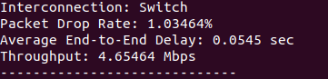

Figure 40 Switch Interconnection

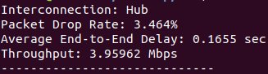

Figure 41 Hub Interconnection

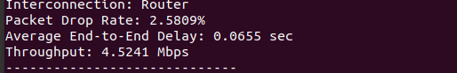

Figure 42 Router Interconnection



Figure 43 Tracefile : Switch



Figure 44 Tracefile : Hub



Figure 45 Tracefile : Router

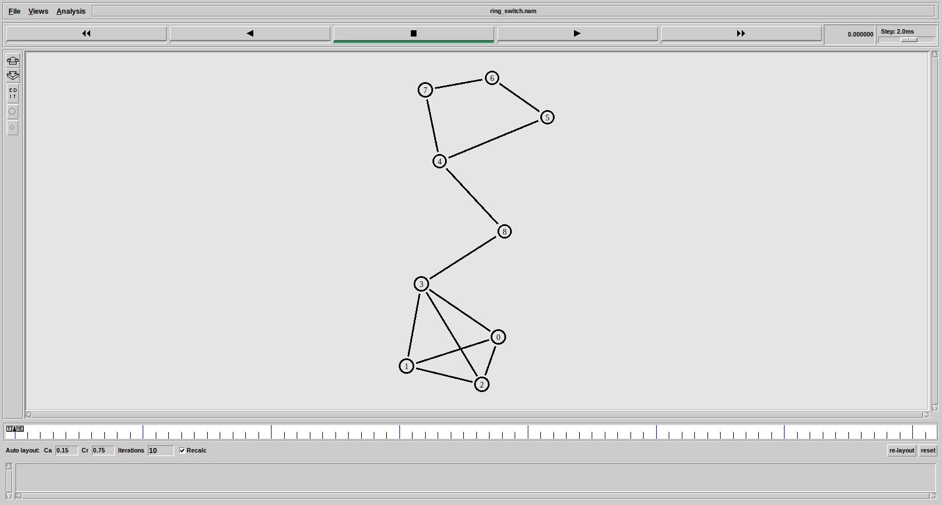

Figure 46 Ring LAN and Mesh LAN Interconnected by Switch

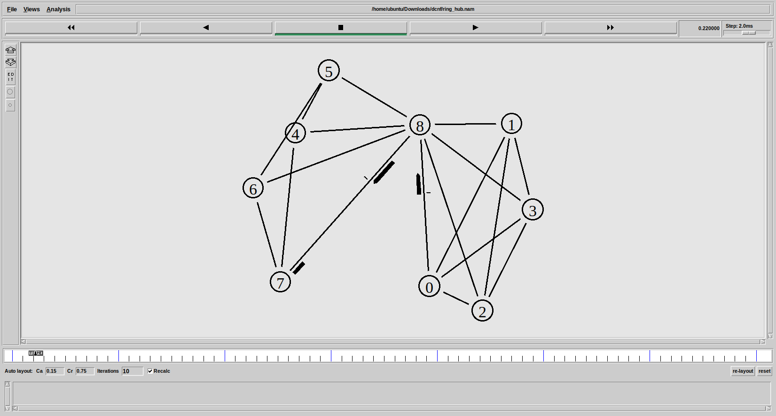

Figure 47 Mesh LANs Interconnected by Hub

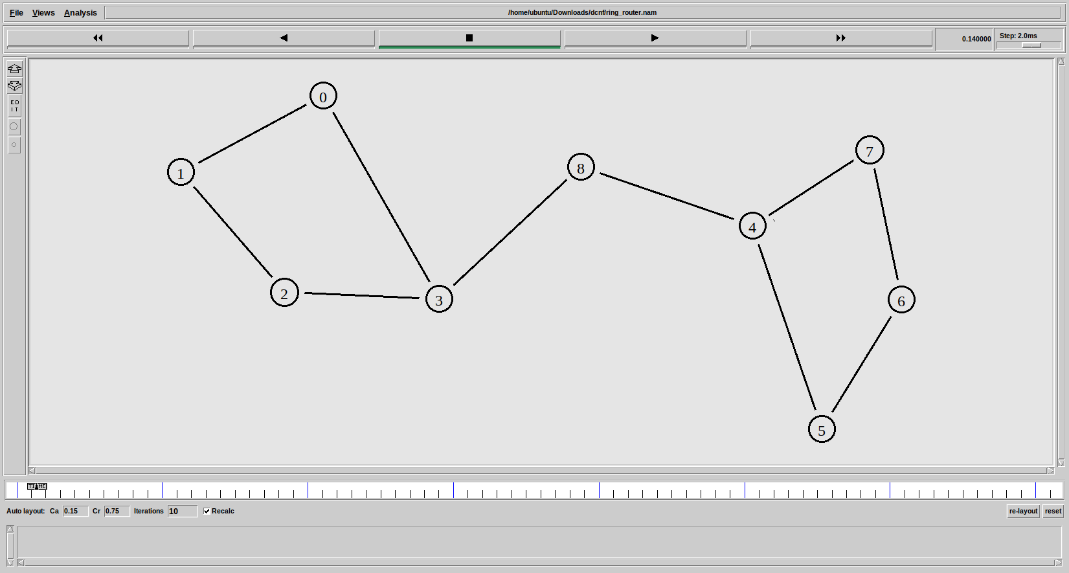

Figure 48 Ring LANs Interconnected by Router

**RESULT:**

Simulation and Comparison of Various LAN Interconnections (Switch, Hub, Router) is Done Using NS2 Software.